If you are interested in volunteering to help or participating in activities, please contact the Health and Wellbeing Team on 01670 784800


Our mission is:
‘To promote the wellbeing of people over the age of 50 in and around the county of Northumberland, helping to make life enjoyable and fulfilling’.

Age UK Northumberland
The Roundhouse
Lintonville Parkway
Ashington
NE63 9JZ
01670 784800

E-mail info@ageuk-northumberland.org.uk
www.ageuk.org.uk/northumberland

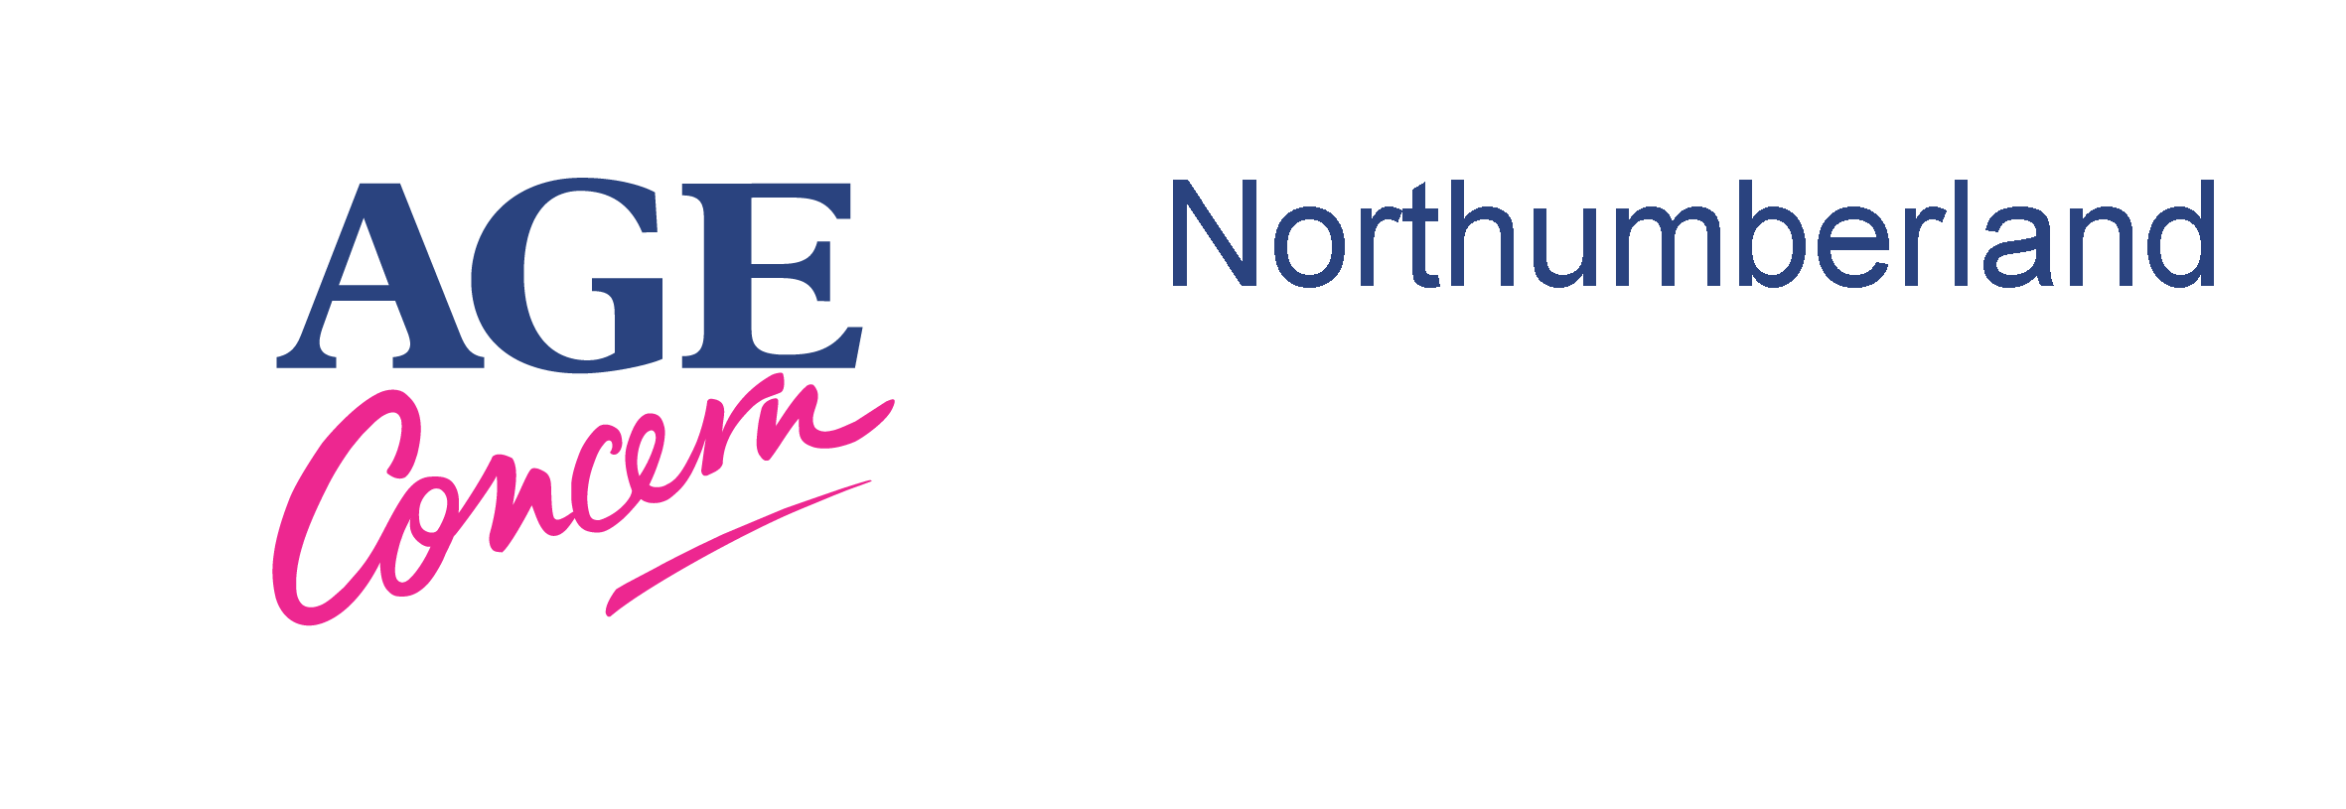

Health and Wellbeing

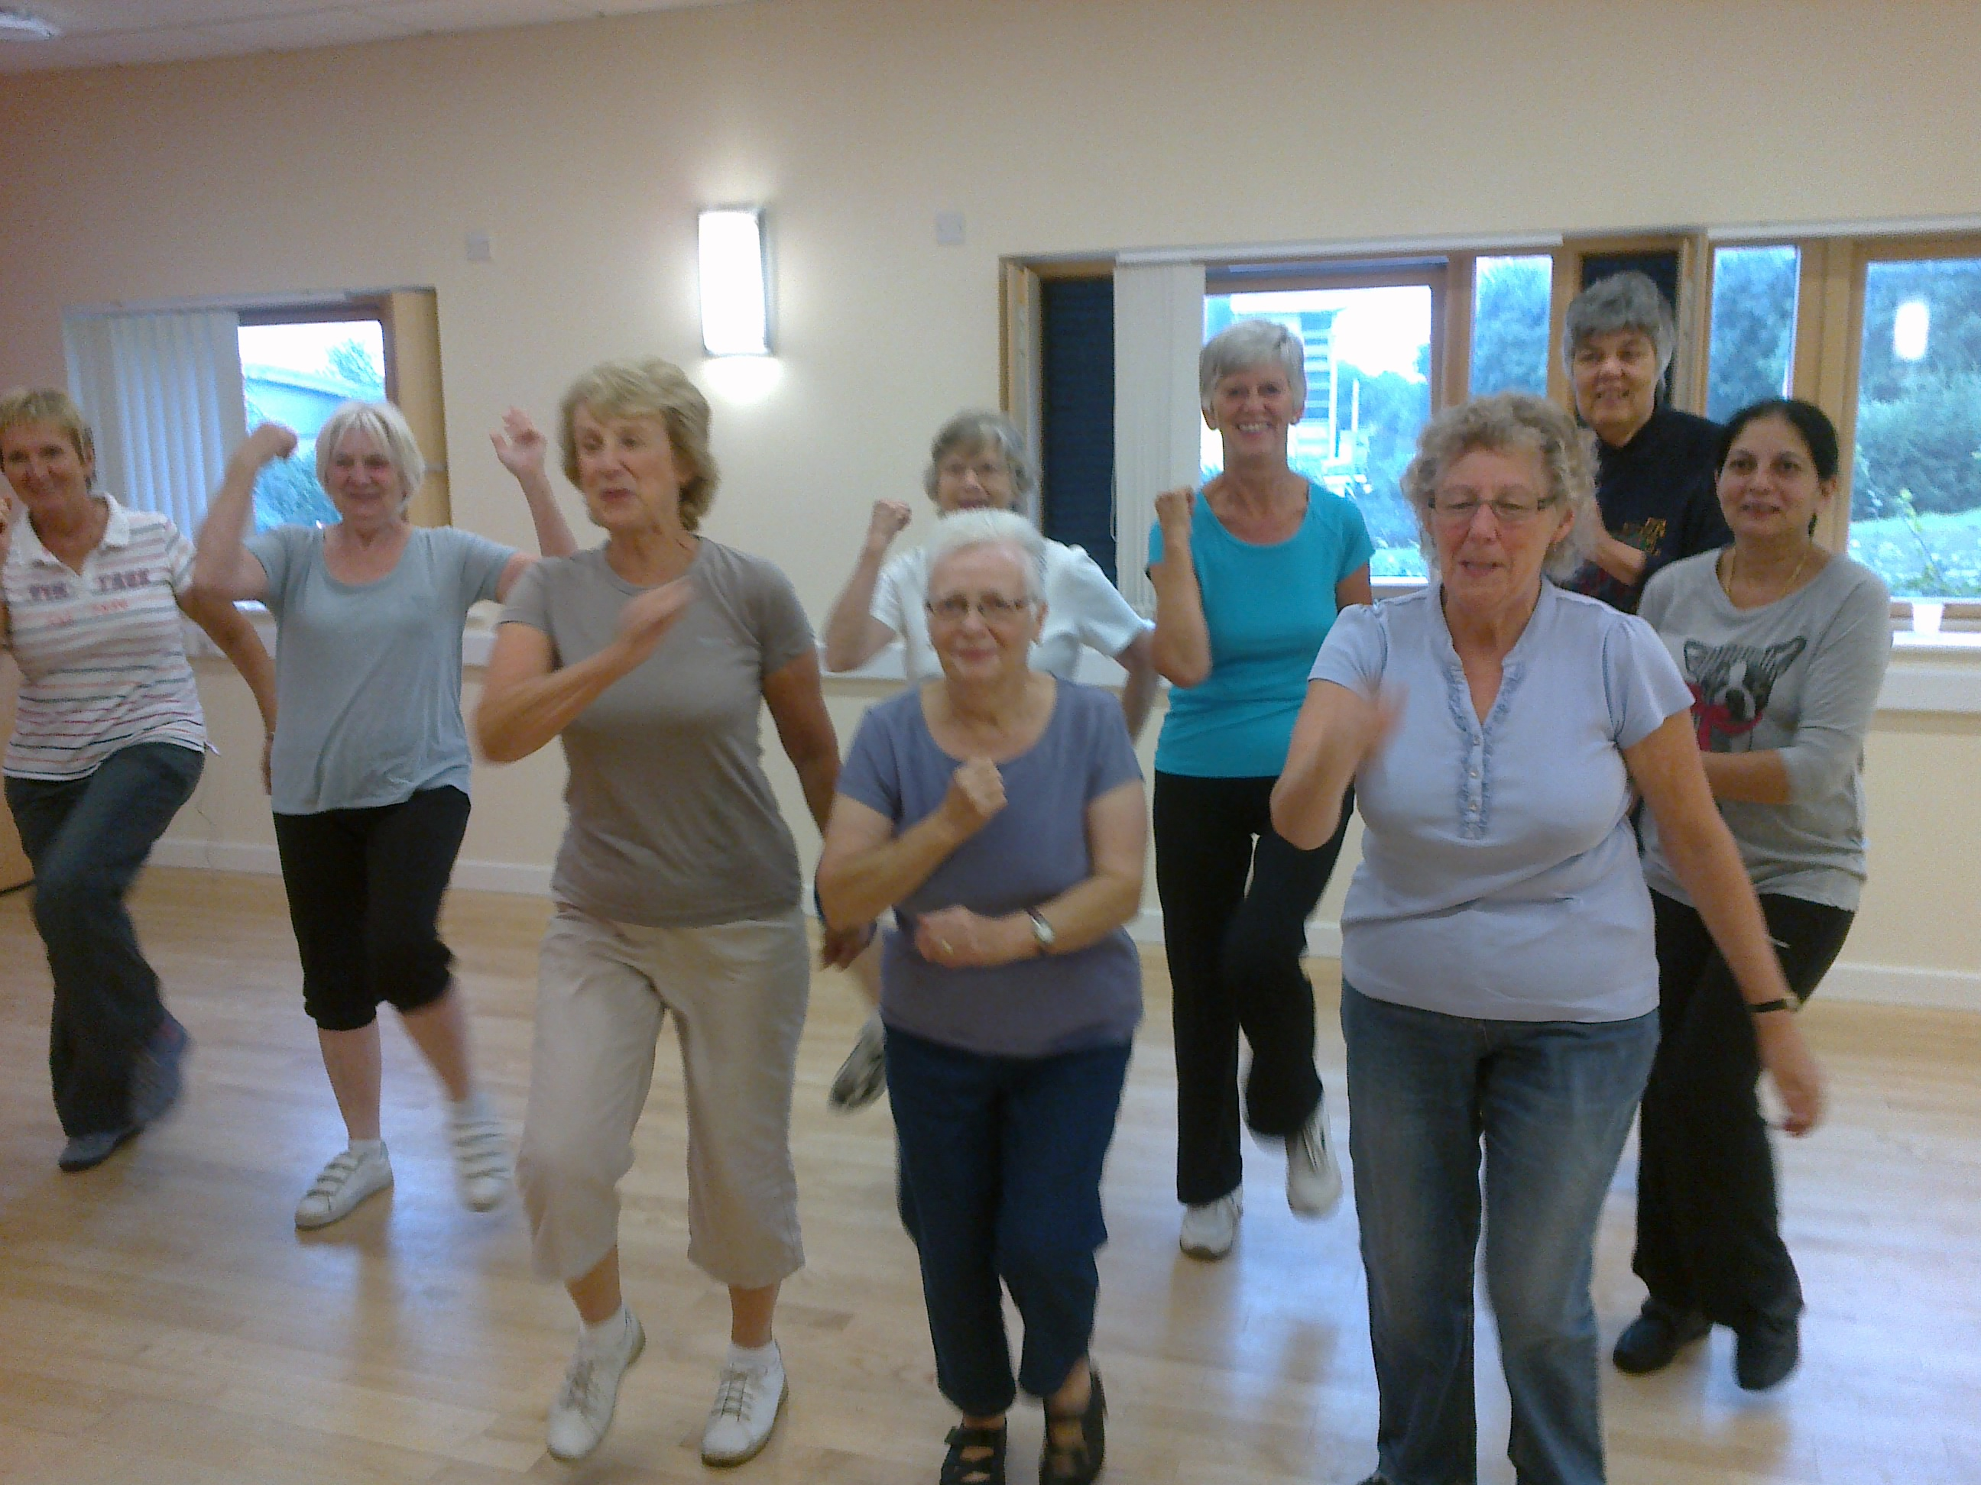

Improving and maintain the health, wellbeing and independence of older people in Northumberland.
We know that maintaining health, wellbeing and independence in later life can have huge long term benefits and as a result we have a well-developed program providing a wide range of physical activity classes specifically designed to help older people maintain and improve fitness levels.

We currently have 49 exercise classes run in community settings across Northumberland offering a wide range of activities. These are delivered by trained exercise volunteers and accessed by around 700 people a year.

Chair Based Exercise
Exercise to Music
COPD
Circuits
Zumba
Falls Prevention Classes

Activities we offer…
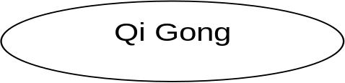
The classes provide hugely enjoyable, interactive sessions with a great atmosphere that encourage participants to exercise at their own level and set realistic goals.

Volunteers offer support and encouragement to their peers and provide a range of activities for older people to participate in.

We can also provide information and assistance to individuals and groups.
To find out about a class in your area please contact Anne Robinson or Angie Patrick on 01670 784800

