
Providing Retirement Housing
in Mid Sussex
SPRING COPSE

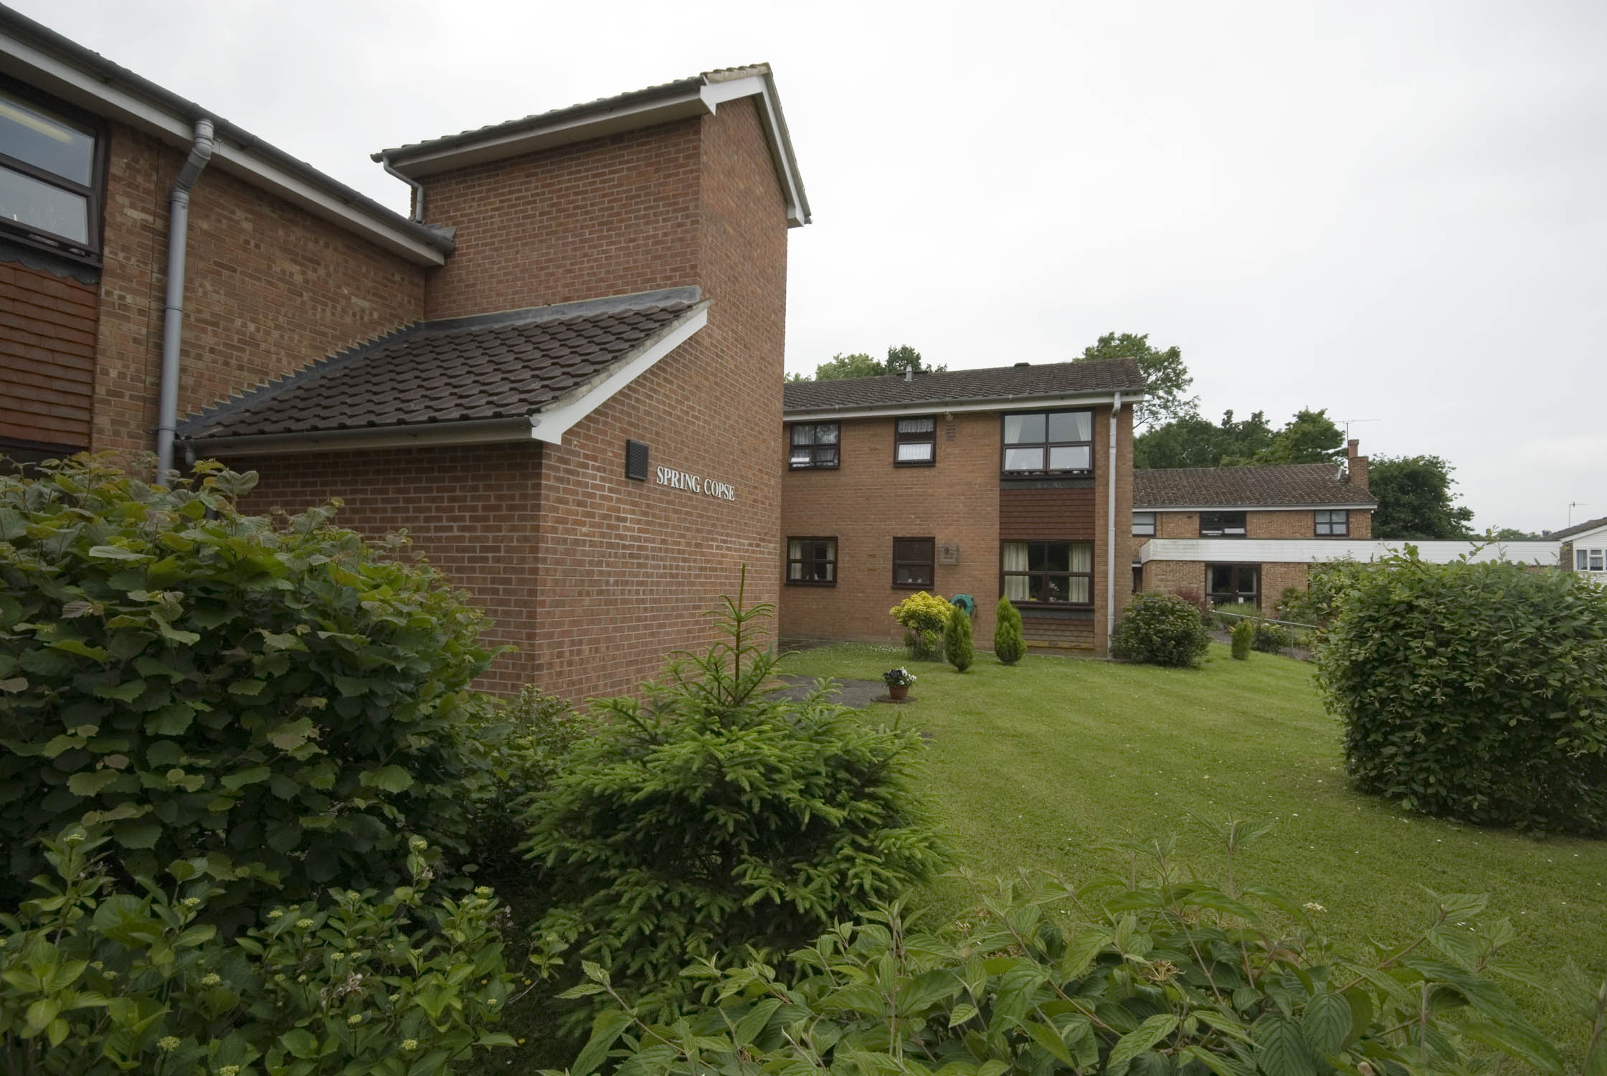

The Weald
East Grinstead
West Sussex
RH19 3HF

Telephone:
01342 324732

About the scheme
Spring Copse is located in the town of East Grinstead. The scheme has 39 homes specifically designed for older people, and offers an opportunity for independent living in a safe, comfortable and secure environment.

The scheme is set over two floors with stairs leading to the first floor accommodation. The homes are a mixture of one bedroom flats, and studio apartments.

Within walking distance of the scheme there is a general store, post office®, fish and chip shop and GP surgery, and a chemist that will deliver prescriptions to Spring Copse. The bus stop located near to the scheme will take you into East Grinstead town, or into near by Crawley where there is a huge variety of shops and facilities available.

There is also a mini bus that collects and returns residents back to the scheme following a few hours shopping at a near by supermarket.

Facilities

- 39 homes
- 24 emergency support, 7 days a week, via our staff and our in house control centre
- Security door entry to the main front door that can be operated from each flat
- Communal lounge with kitchen, where regular coffee mornings and video shows take place.
- Pretty Communal gardens
- Communal laundry room, with washing machine and dryers for residents use
- Treatment room for visiting hairdresser and chiropodist
- Guest suite for resident’s relatives and friends for a small charge
- A mobile library visits

Who can apply?

Spring Close has been designed for older people or those with disabilities.
How to apply

Applications should be made to Mid Sussex District Council – unless you are currently an Affinity Sutton resident

Contact details

To find out more, or to arrange a visit, please contact the scheme manager on 01342 324732, or our Customer Services Team on 0845 688 7717.

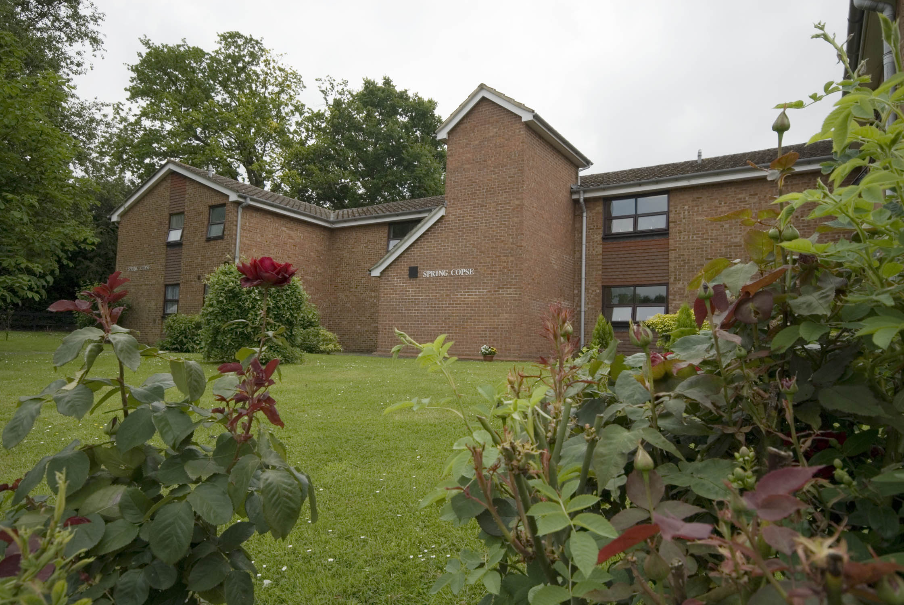


Registered office: Level 6, 6 More London Place, Tooley Street, London, SE1 2DA
www.affinitysutton.com

