
Providing Retirement Housing
In Mid Sussex
SHEDDINGDEAN COURT

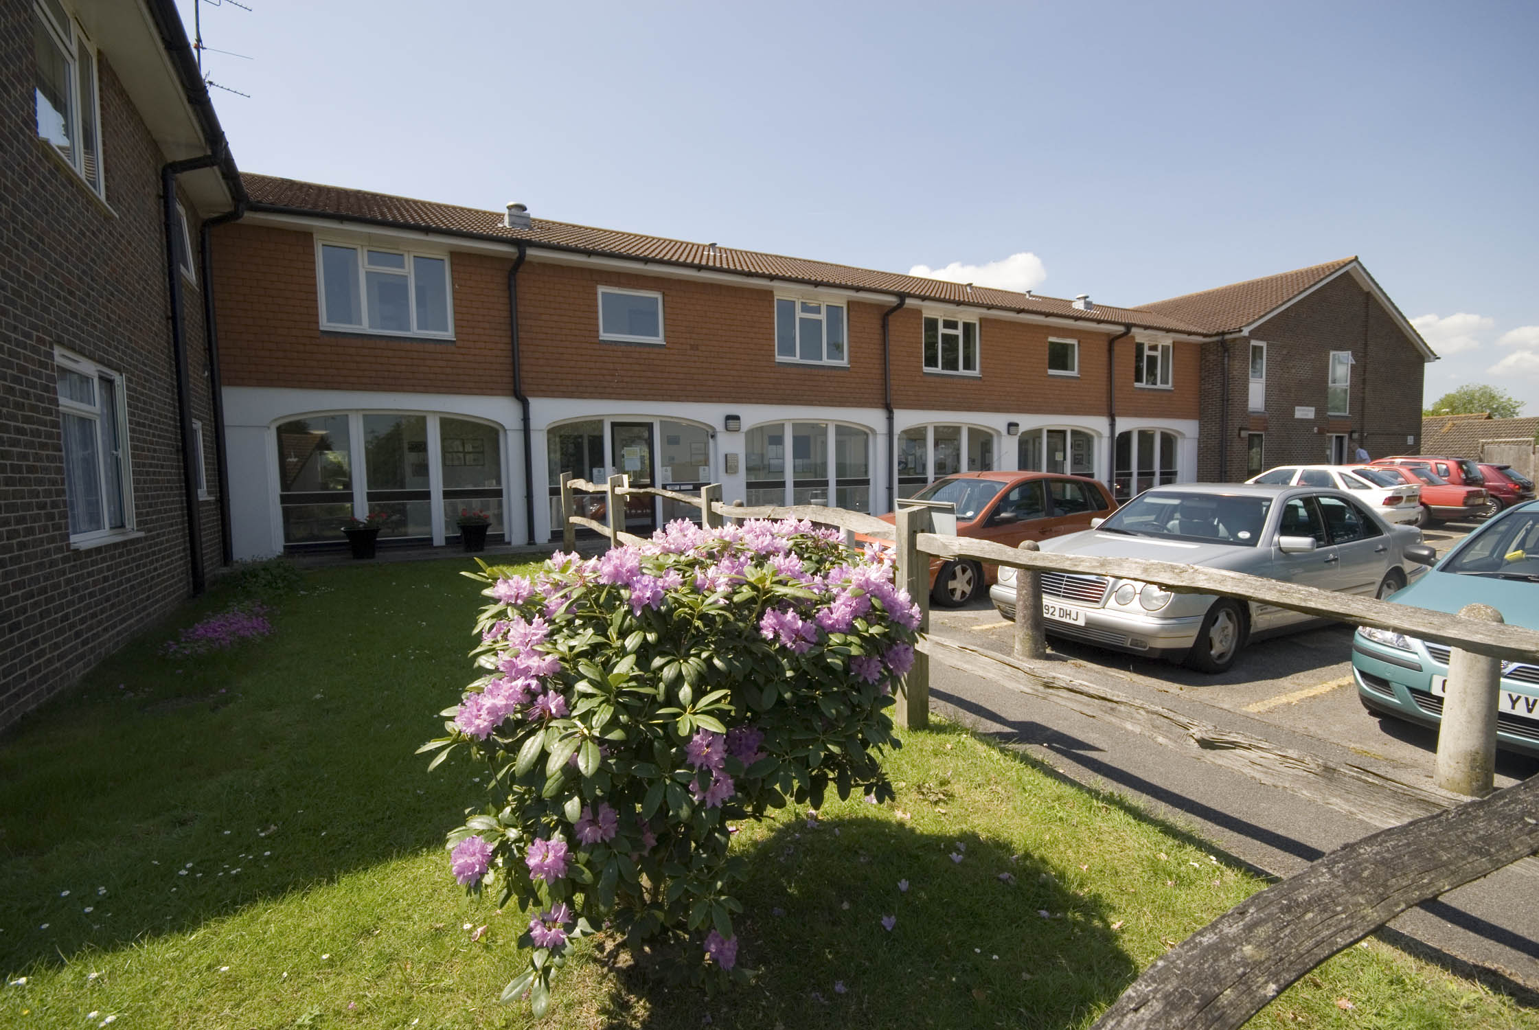

Packham Way
Burgess Hill
West Sussex
RH15 8PZ

Telephone:
01444 247308

About the scheme
Sheddingdean Court is situated in the bustling town of Burgess Hill.
The scheme has 34 homes specifically designed for older people, and offers an opportunity for independent living in a safe, comfortable and secure environment.

The scheme is set out over two floors with lift and stairs leading to the first floor accommodation. The properties are all one bedroom flats, all have gas central heating and are all fully double glazed. There is also one, two bedroom flat as well.

The main town of Burgess Hill offers a large range of shops and amenities and is easily accessible by bus. The bus stop nearby to the scheme not only covers the local area, but other areas such as Brighton. There are several GP surgeries and chemists with a delivery service located throughout the Burgess Hill area. There is also a main train station at Burgess Hill, which can take you to towns and cities further afield as well as to central London

Facilities

- 34 homes
- 24 hour emergency support, 7 days a week, via our staff and our in house control centre
- Security door entry to the main front door that can be operated from each flat
- Lift
- Stunning communal grounds
- Communal lounge with adjoining kitchen
- Communal laundry room with washing machines and dryers for the residents use
- Guest suite available for residents families and friends to use at a small charge
- A community bus calls at the scheme, to transport residents to the local Age Concern Day Centre

Who can apply?

Sheddingdean Court has been specifically designed for older people, or those with disabilities.
How to apply

Applications should be made to Mid Sussex District Council, unless you are currently an Affinity Sutton resident

Contact details

To find out more, or to arrange a visit, please contact the Scheme Manager on 01444 247308 or our Customer Service Team on 0845 688 7717.

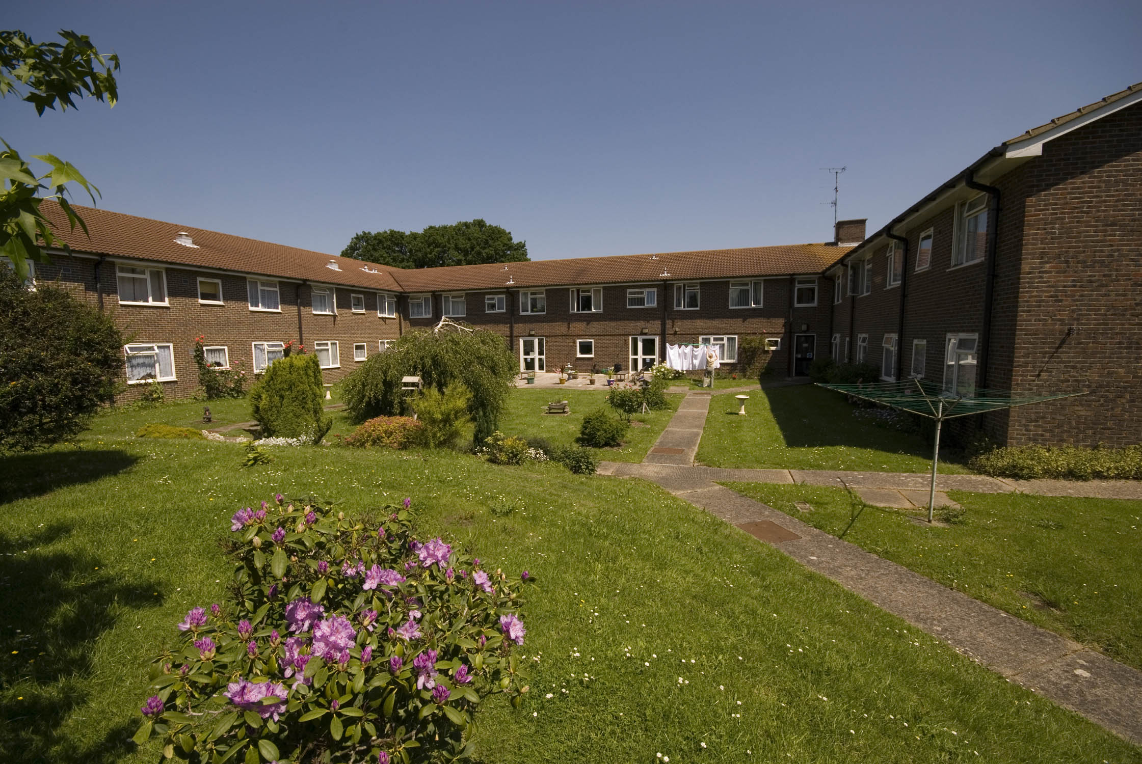


Registered office: Level 6, 6 More London Place, Tooley Street, London, SE1 2DA
www.affinitysutton.com

