
Providing Retirement Housing
in Mid Sussex
RIBBETTS HOUSE

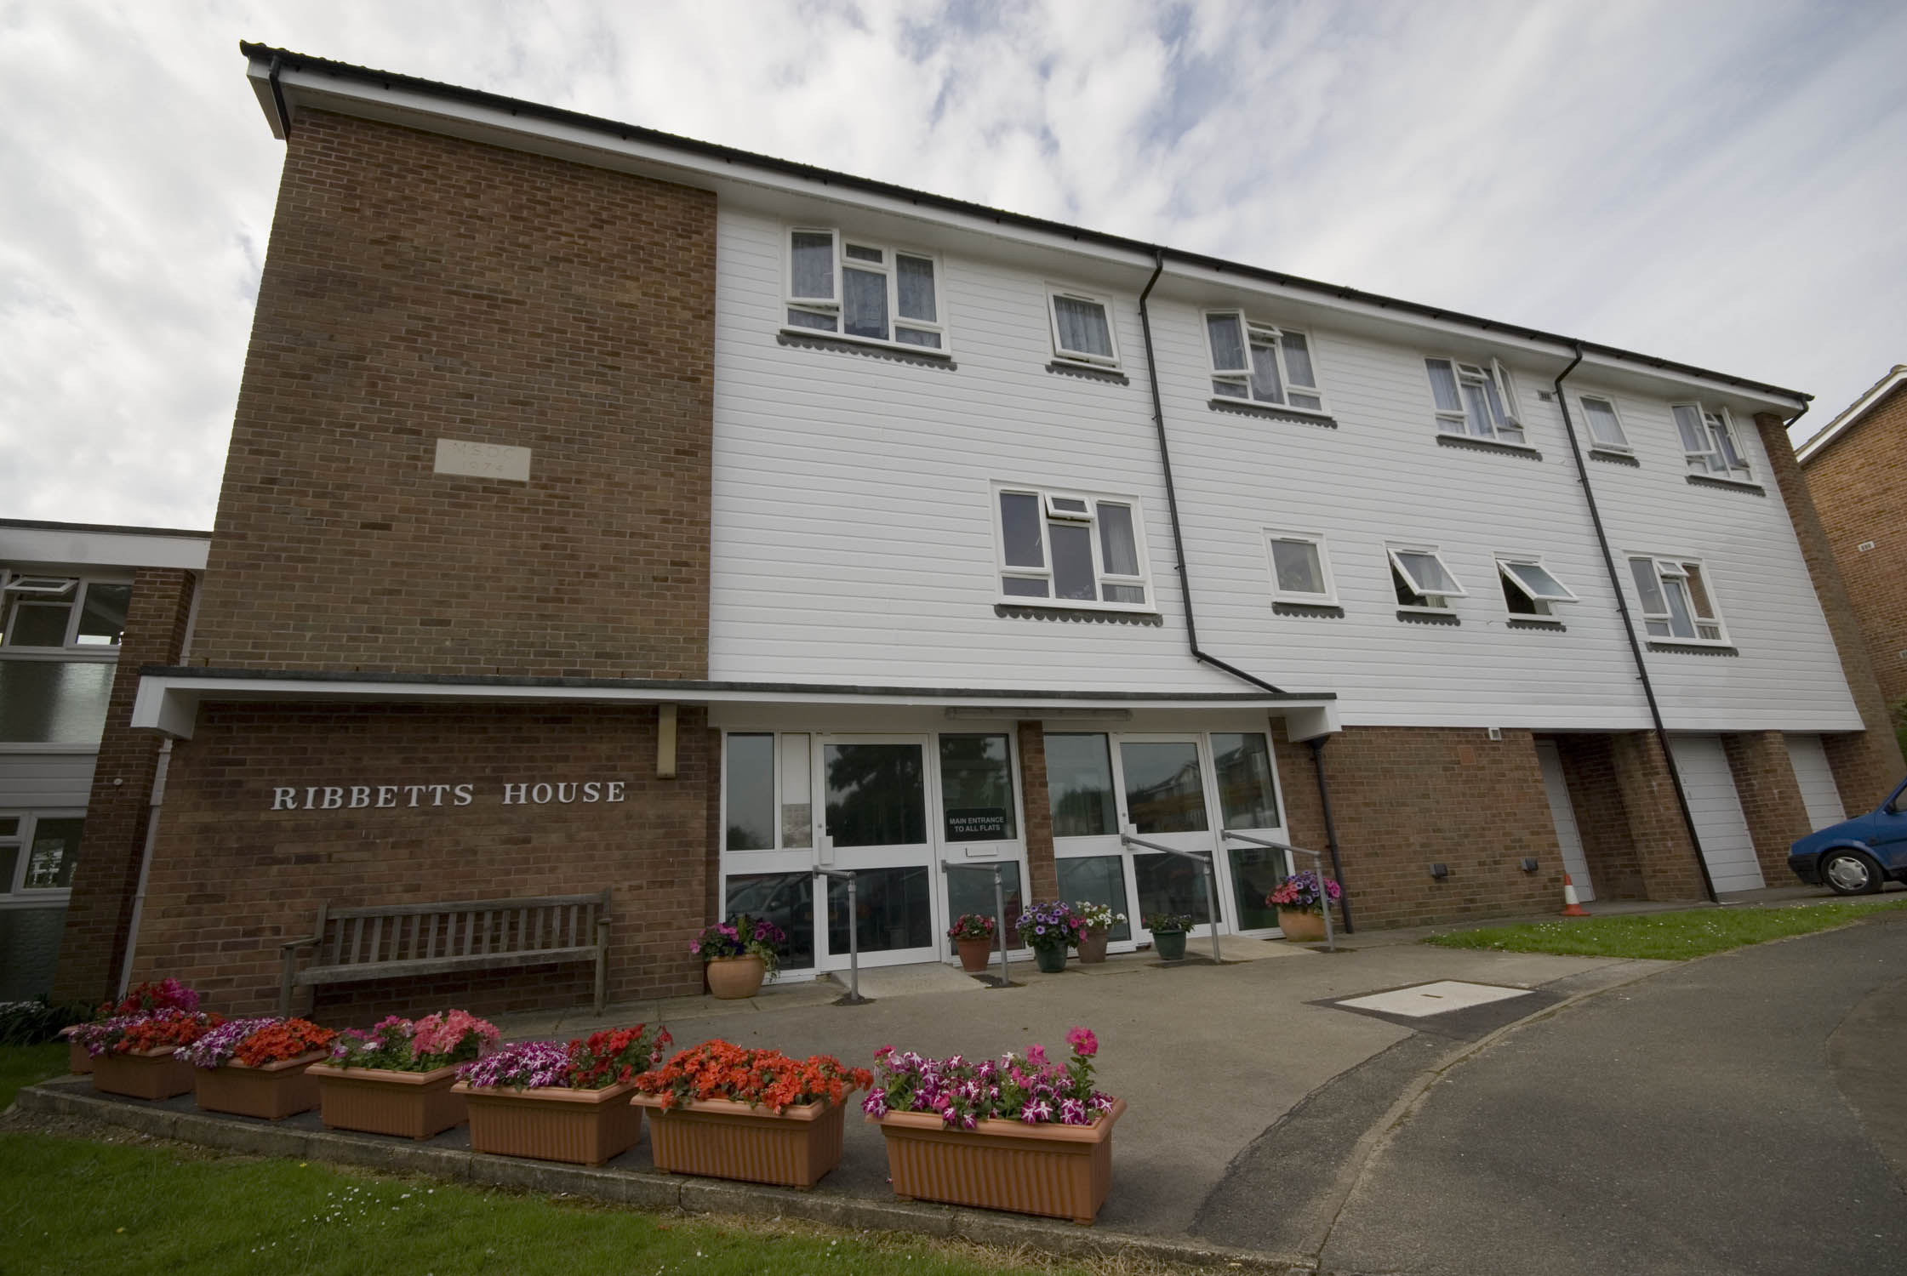

Trinity Road
Hurstpierpoint
West Sussex
BN6 9XE

Telephone:
01273 834089

About the scheme
Ribbetts House is located in the pretty village of Hurstpierpoint. The scheme has 34 homes specifically designed for older people, and offers an opportunity for independent living in a safe, comfortable and secure environment.

The scheme is set over three floors, with lifts and stairs giving access to the upper floors. The properties are a mixture of one and two bedroom properties.

A short stroll from the scheme, in Hurstpierpoint village there are several shops, a chemist, hairdresser, post office® and GP surgery.

There are local buses running from the village on a regular bases, to Hassocks, Haywards Heath, Brighton and Crawley. There are also several free buses travelling to and from nearby superstores.

Facilities

- 34 homes
- 24 emergency support, 7 days a week, via our staff and our in house control centre
- Security door entry to the main door that can be operated from each flat
- Lift
- Gas Central Heating
- Large communal lounge with adjoining kitchen, where various events are held
- Communal laundry room with washing machines and tumble dryers for the residents
- Guest suite available for residents family and friends to use at a small charge

Who can apply?

Ribbetts House is a scheme that has been designed for older people or those with disabilities.
How to apply

Applications should be made to Mid Sussex District Council - unless you are currently an Affinity resident

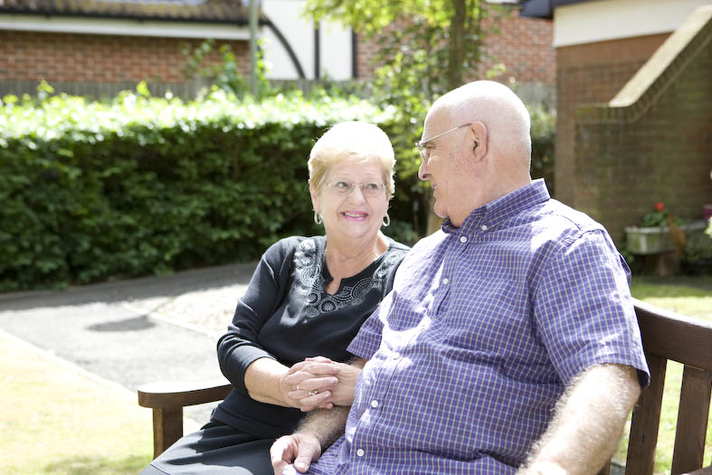
Contact details

To find out more, or to arrange a visit, please contact the scheme manager on 01273 834089, or our Customer Service Team on 0845 688 7717.


Registered office: Level 6, 6 More London Place, Tooley Street, London, SE1 2DA
www.affinitysutton.com

