
Providing Retirement Housing
in Mid Sussex
OAKLEE

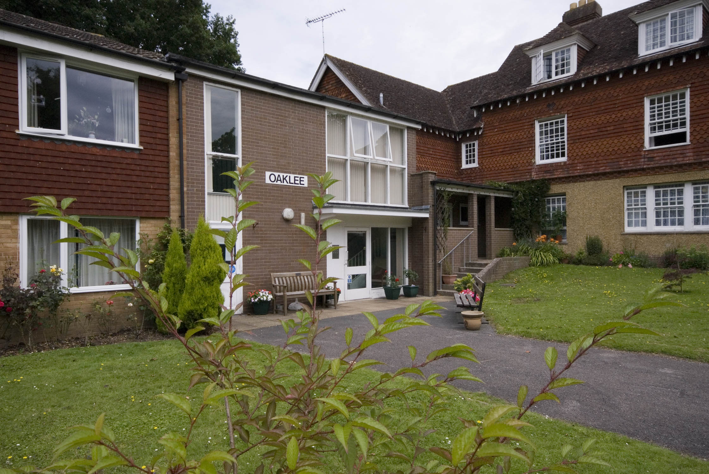

Compton Road
Lindfield
West Sussex
RH16 2PF

Telephone:
01444 484296

About the scheme
Oaklee is situated in the beautiful village of Lindfield Heath, which is approximately five minutes by car from Haywards Heath. The scheme has 22 homes specifically designed for older people, and offers an opportunity for independent living in a safe, comfortable and secure environment.

The scheme is set out over two floors with stairs leading to the first floor accommodation. The properties are one bedroom flats and studio flats.

Within a short walk of the scheme Lindfield village centre provides a good range of facilities for our residents, including a post office®, various shops and a GP surgery. There is also an historic church dating back to 1098, a tranquil pond graced by wildfowl and large open common that is used to host a variety of village events.

There are excellent bus links to nearby Haywards Heath and the surrounding areas, and a station there to, which will take you to towns further afield and to central London.

Facilities

- 22 homes
- 24 hour emergency support, 7 days a week, via our staff and our in house control centre
- Security door entry to the main front door that can be operated from each flat
- Night storage heaters
- Large communal lounge with adjoining kitchen for the residents use. Which is used throughout the year for a variety of events
- Communal laundry room with washing machines and dryers for residents use
- Treatment room which is used for visiting hairdresser, chiropodist and the District Nurse
- Guest suite is available for resident’s families and friends to use for a small fee.
- Pretty communal garden

Who can apply?

Oaklee has been designed for older people or those with disabilities.
How to apply

Applications should be made to Mid Sussex District Council - unless you are currently an Affinity Sutton resident.

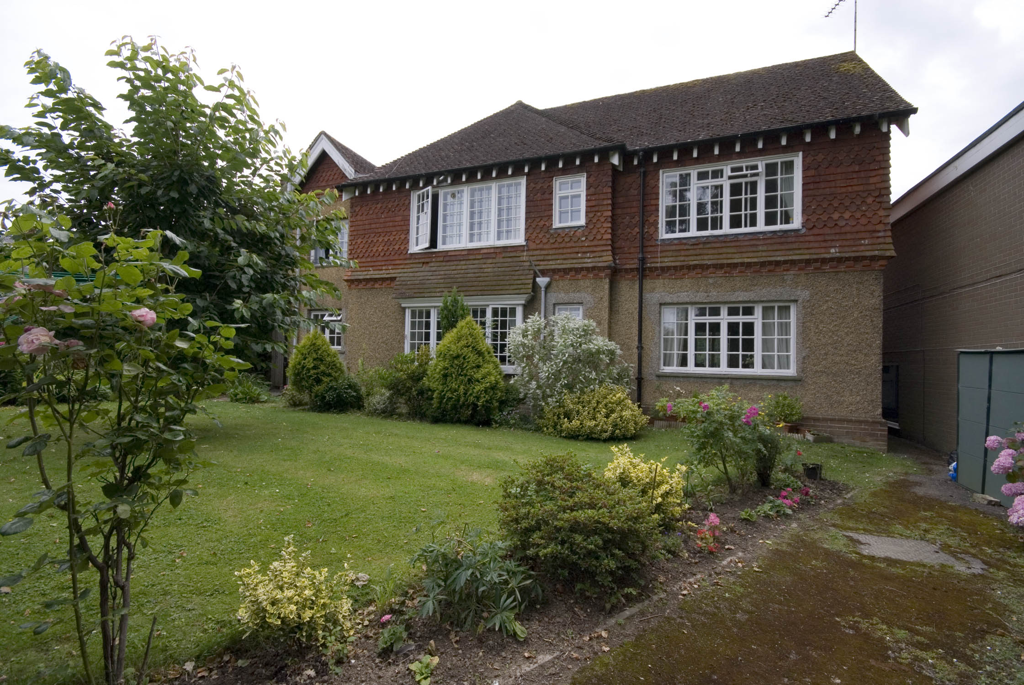
Contact details

To find out more, or to arrange a visit, please contact the scheme manager on 01444 484296, or our Customer Services Team on 0845 688 7717.


Registered office: Level 6, 6 More London Place, Tooley Street, London, SE1 2DA
www.affinitysutton.com

