
Providing Retirement Housing
in Mid Sussex
MAYFLOWER COURT

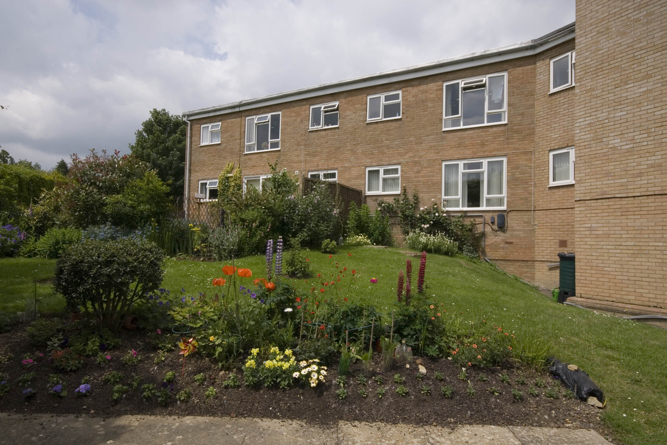
New England Road
Haywards Heath
West Sussex
RH16 3JP

Telephone:
01444 451253

About the scheme
Mayflower court is located in the town of Haywards Heath. The scheme has 28 homes specifically designed for older people, and offers an opportunity for independent living in a safe, comfortable and secure environment.

The scheme is set out over two floors with lifts and stairs to the first floor accommodation. There is a mixture of one and two bedroom flats, with all the properties having gas central heating and double glazing.

Haywards Heath town is within easy walk of the scheme. Locally to Mayflower Court, there is a GP surgery, library and Hospital. A regular bus service operates within the town and outlying villages, such as Lindfield and Cuckfield. There is a main line station offering links to London and Brighton.

Facilities

- 28 homes
- Lift
- 24 hour emergency support offered, 7 days a week, via our staff and our in house control centre
- Communal lounge and adjoining kitchen, where a huge variety of activities take place
- Security door entry to the main front door that can be operated from each flat
- Communal laundry room with washing machine and dryer for residents use
- Guest suite available for relatives and friends of residents
- Visiting hairdresser and chiropodist

Who can apply?

Mayflower Court has been designed for older people or those with disabilities.
How to apply

Applications should be made to Mid Sussex District Council – unless you are currently an Affinity Sutton resident

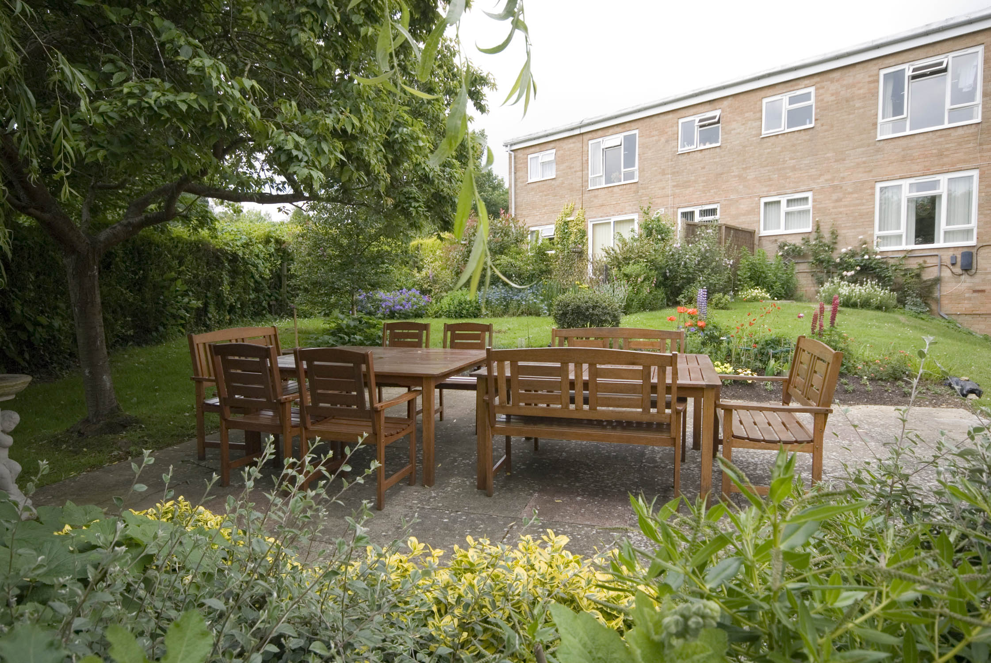
Contact details

To find out more, or to arrange a visit, please contact the scheme manager on 01444 451253 or our Customer Services Team on 0845 688 7717.
.


Registered office: Level 6, 6 More London Place, Tooley Street, London, SE1 2DA
www.affinitysutton.com

