
Providing Retirement Housing
in Mid Sussex
THE GABLES

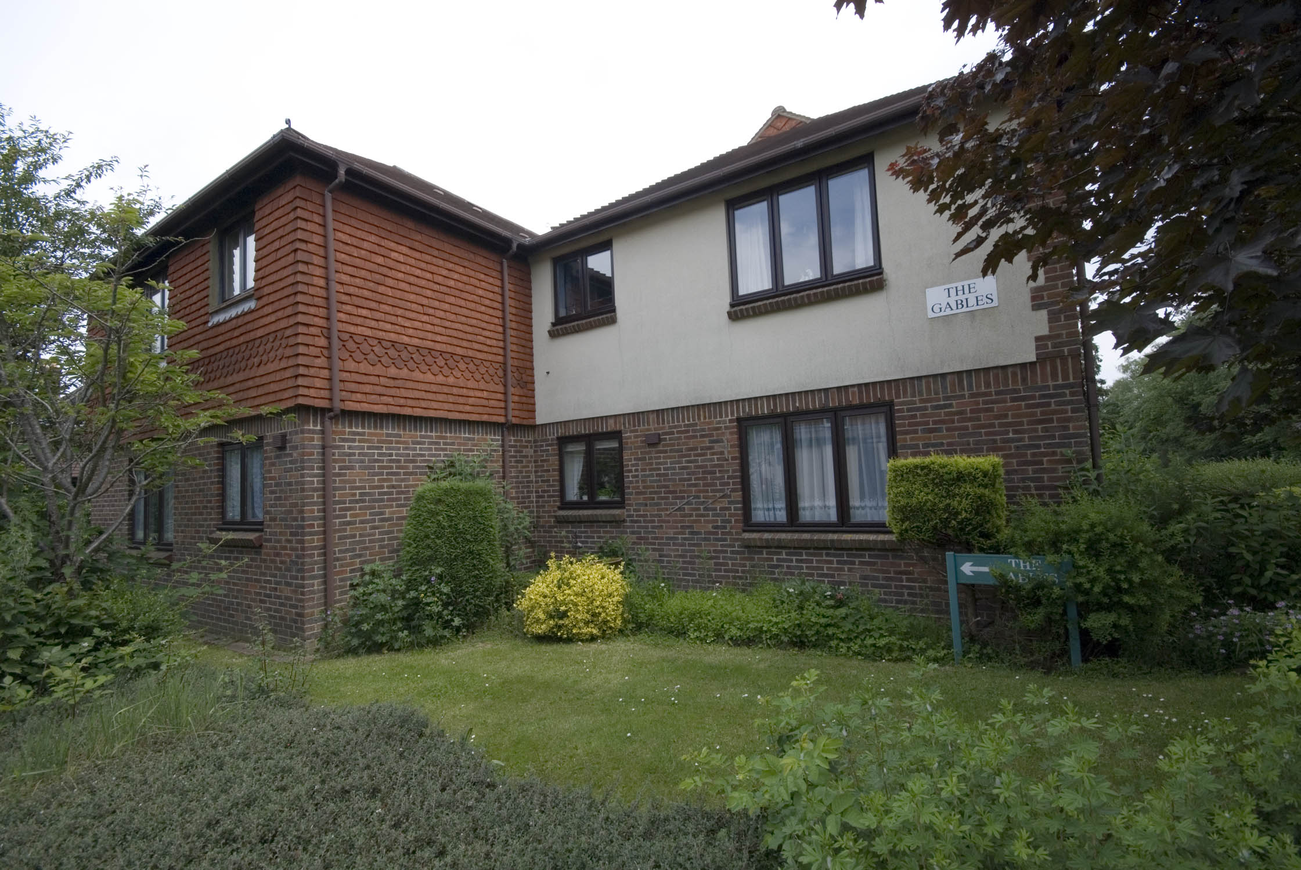

Newtown
Copthorne
West Sussex
RH10 3NA

Telephone:
01342 713327

About the scheme
The Gables is situated on the edge of Copthorne Village. The scheme has 24 homes specifically designed for older people, and offers an opportunity for independent living in a safe, comfortable and secure environment.

The scheme is set out over two floors with stairs leading to the first floor accommodation, which consist of one bedroom flats and studio apartments offering bright and spacious living.

A short walk from The Gables is the village centre which has a post office®, chemist, GP surgery, various shops, including the village hall and health club.

There is a regular bus service that runs from the village to the nearby towns of East Grinstead and Crawley. There are train stations located in both these towns that offers access to Brighton, central London and the surrounding area.

Facilities
- 24 homes
- 24 hour emergency support, 7 days a week, via our staff and our in house control centre
- Security door entry to the main front door that can be operated from each flat
- Gas central heating
- Communal lounge with adjoining kitchen where regular events are held
- Communal laundry room with washing machines and dryers for the residents to use
- Treatment room for visiting hairdresser
- Chiropodist visits scheme
- Guest suite available for residents family and friends for a small charge
- Mobile Library visits
- Regular sales at the scheme, including clothing, gifts and popular books

Who can apply?

The Gables has been designed for older people or those with disabilities.
How to apply

Applications should be made to Mid Sussex District Council – unless you are currently an Affinity Sutton resident.

Contact details

To find out more, or to arrange a visit, please contact the scheme manager on 01342 713327, or our Customer Service Team on 0845 688 7717.

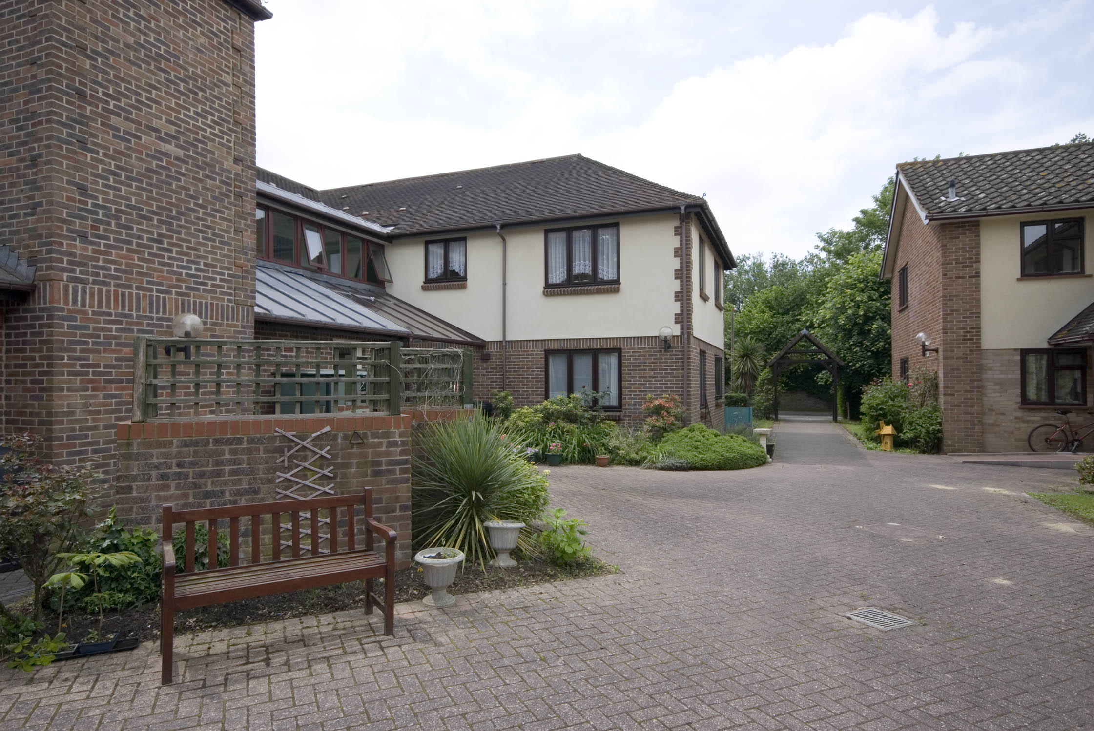

Registered office: Level 6, 6 More London Place, Tooley Street, London, SE1 2DA
www.affinitysutton.com

