
FURTHER INFORMATION

If you’re aged over 60 and living independently, either as a single person or as a couple, but are looking for the added peace of mind that sheltered housing provides, you could be eligible for accommodation and support at Vernon House

ABOUT ECHG
‘ECHG cares passionately about making a difference for our clients. We combine our passion with a business-like approach to deliver quality services and solutions for our customers

.

MAP & DIRECTIONS

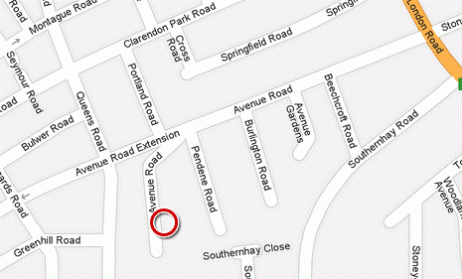
VERNON

Vernon House is situated at the end of a quiet cul de sac, in Avenue Road. Stoneygate, Leicester and is close to shops, a post office and bus routes.

You can find out more or apply to go on our waiting list…

By calling our 24 hour customer service centre on 0845 155 9002
HOUSE

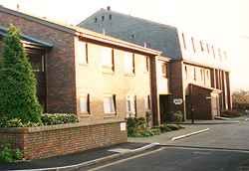

Run by ECHG
Vernon House is a Sheltered Housing Scheme in Leicester for people over 60 years of age




ABOUT VERNON HOUSE
ECHG’s Vernon House is a sheltered housing scheme for people over 60 years of age living independently but with the added security of 24 hour cover provided through a central control system and an on-site scheme manager.

Support: The Scheme manager works 37.5 hours a week Monday to Friday; but this is flexible to meet the needs of the scheme. During the working day they are required to spend most of their time at the scheme, but there may be occasions when they have to leave the scheme for professional training, meetings etc The Scheme manager is employed to ensure that the scheme runs smoothly and efficiently, ensuring repairs are carried and offering help and advice to tenants. The Scheme manager encourages tenants to take an active part in the running of their scheme by helping them to arrange social events and outings themselves. The Scheme manager also acts as the first point of contact for visitors to ensure scheme security is maintained.

Social Activities
Regular social activities are available at Vernon House such as games evenings, lunches, coffee mornings and outings to places of interest.

Services:
The scheme benefits from a communal lounge, a quiet room, hairdressing room, lift, assisted bathroom, laundry room, guest room and door entry system.
Accommodation:
Vernon House comprises 20, 1 bed flats suitable for single persons or couples.

Rent, support & service charges vary between £80 and £95 per week and cover the costs of the communal gardener, window cleaner as well as the cost of the 24 hr central control system.

MORE INFORMATION

For more information and
further details please contact:

English Churches
Housing Group (ECHG)
Scheme Manager
1 Vernon House
68 Avenue Road
Leicester
LE2 3EB

Tel: 0116 270 1589

’

