
Providing Retirement Housing
In Mid Sussex
NOAHS COURT

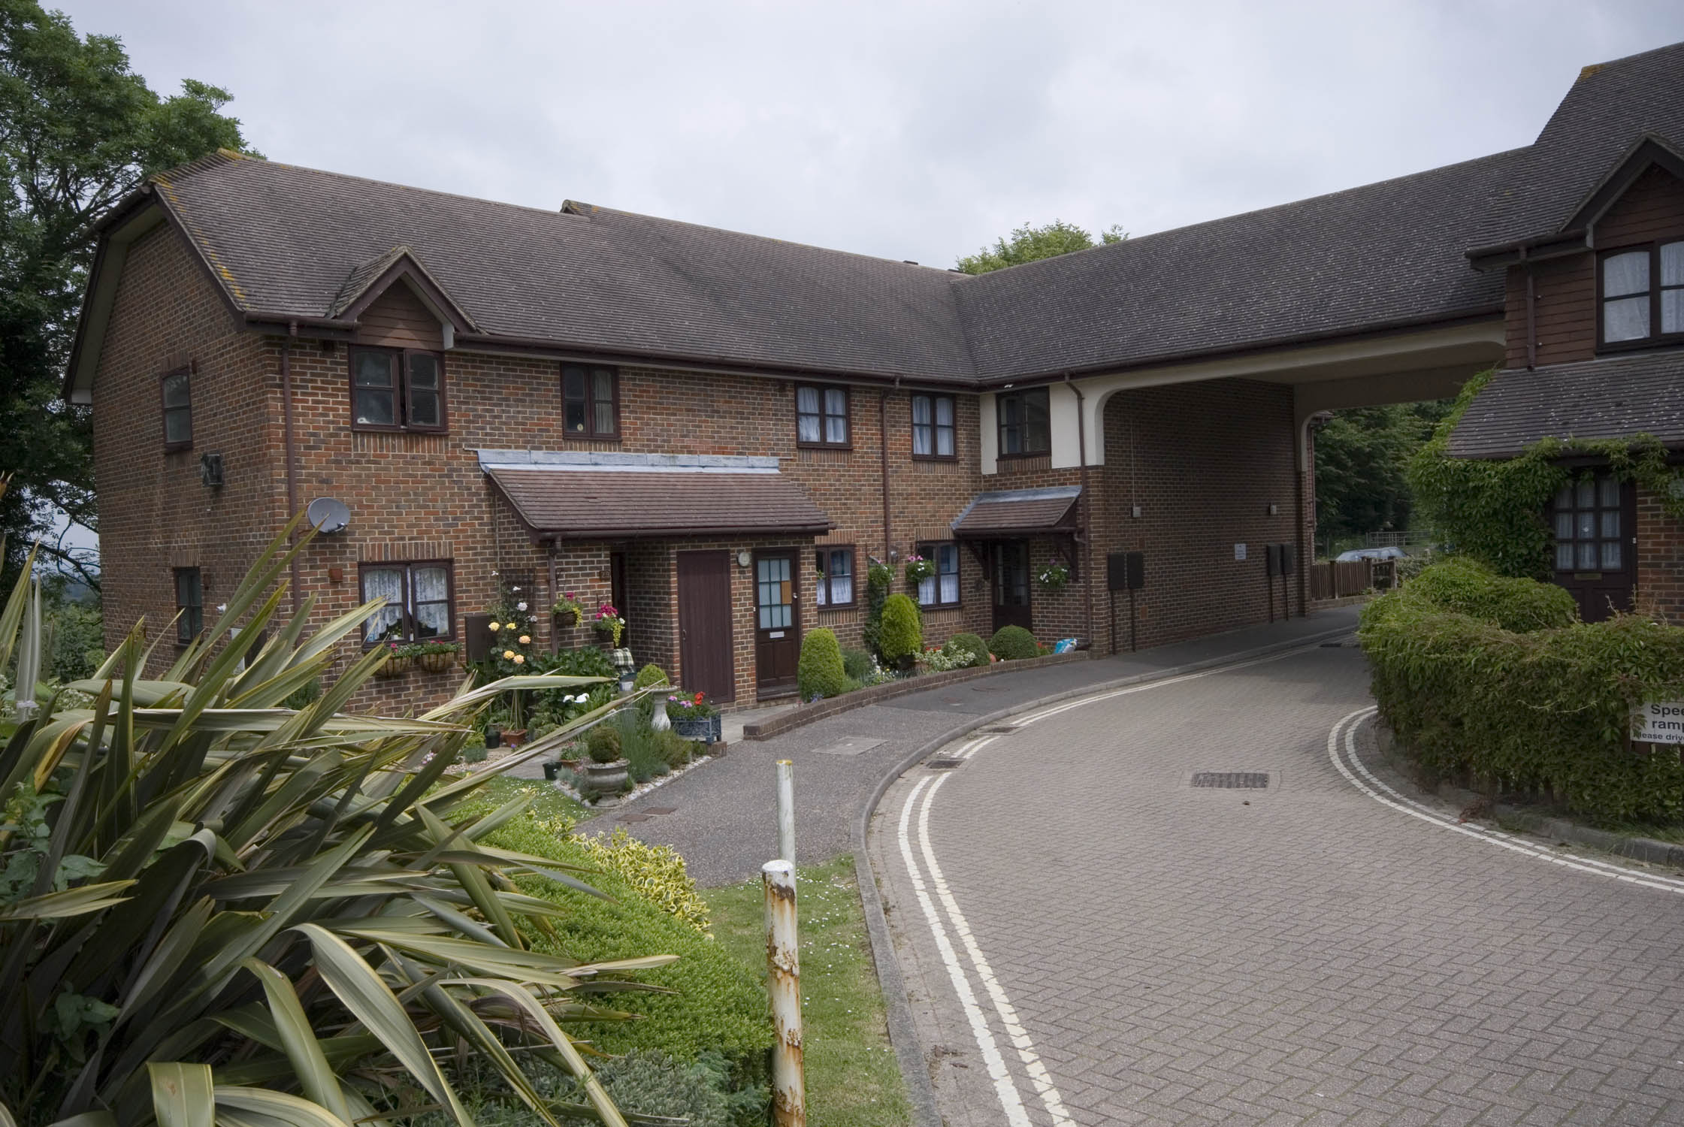

Mount Lane
Turner Hill
West Sussex
RH10 4RE

Telephone:
01342 718921

About the scheme

Noah Court is located in the village of Turner Hill, which is approximately 15 minutes by car from Haywards Heath. The scheme has 24 homes specifically designed for older people, and offers an opportunity for independent living in a safe, comfortable and secure environment.

The scheme is set out over 2 floors with stairs leading to the first floor accommodation. There is a mixture of one bedroom flats and studio apartments through out the scheme.

There is a general store with post office®, a hairdressers and a florist, within a short walk of the scheme. The nearest GP surgery is in the next village, but the general store offers a prescription drop off and collection facility. They can also deliver your groceries if required. There is a very good bus service from the village, to the near by towns of East Grinstead, Crawley and Haywards Heath.

Facilities

- Gas central heating
- 24 hour emergency support, 7 days a week, via our staff and our in house control centre
- Security door entry to the main front door which can be operated from each flat
- Communal lounge with adjoining kitchen, where a variety of functions are held, including coffee mornings, bingo and darts sessions.
- Communal laundry room, with washing machine and dryer for residents use
- Pretty communal garden and residents parking

Who can apply?

Noah Court has been specifically designed for older people or those with disabilities.
How to apply

Applications should be made to Mid Sussex District Council- unless you are currently an Affinity Sutton resident.

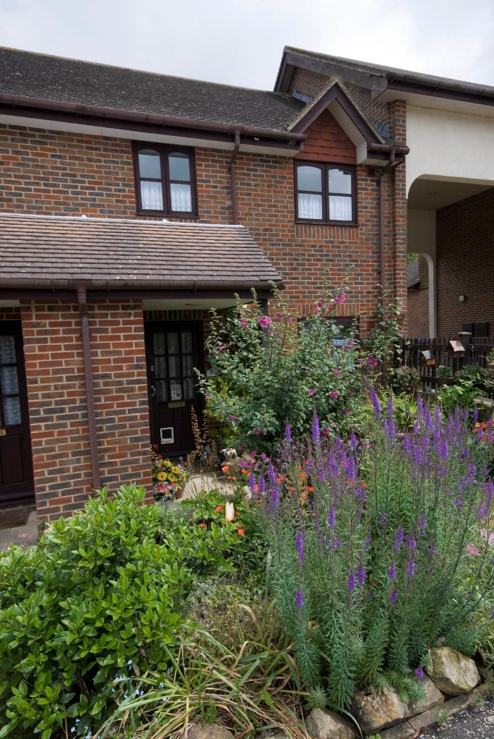
Contact details

To find out more, or to arrange a visit, please contact the scheme manager on 01342 71892, or our Customer Service Team on 0845 688 7717.

Registered office: Level 6, 6 More London Place, Tooley Street, London, SE1 2DA
www.affinitysutton.com

