
Providing Retirement Housing
in Southampton
ROWAN COURT

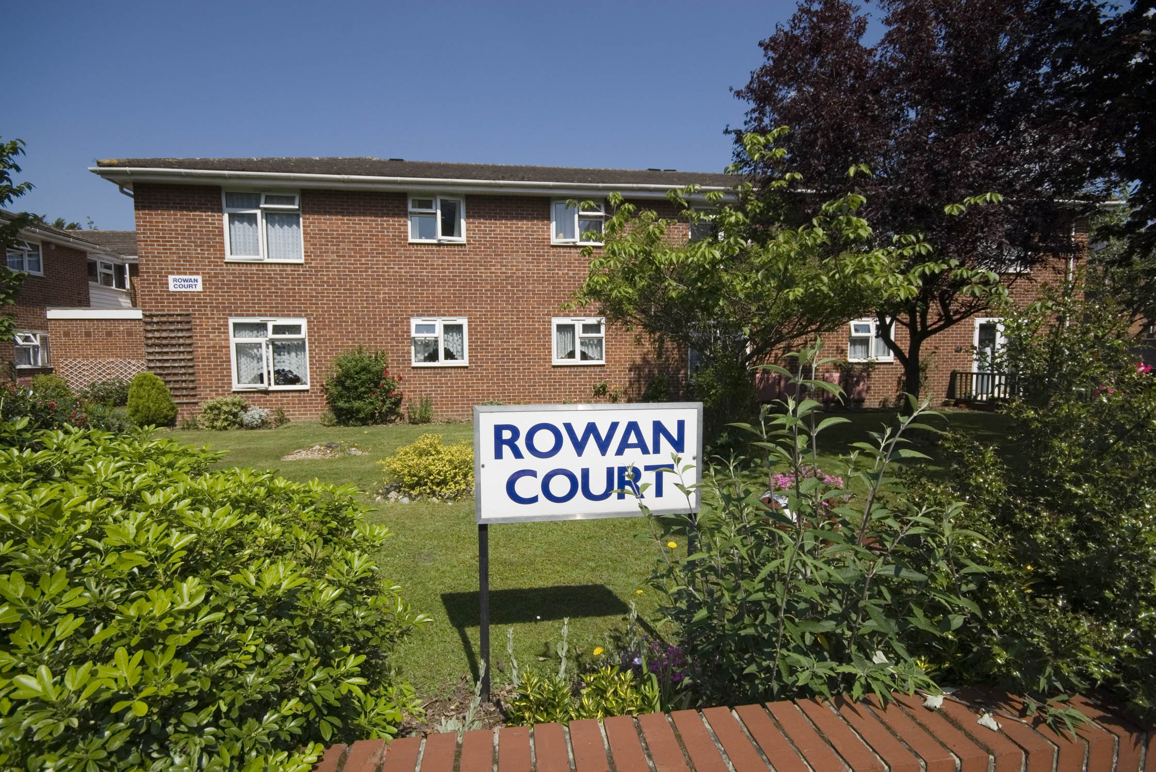

Winchester Road
Shirley
Southampton
Hampshire
SO16 6UD

Telephone:
02380 466490

About the scheme
Rowan Court is located in Shirley, which is a few miles outside of Southampton city centre. The scheme has 18 homes specifically designed for older people, and offers an opportunity for independent living in a safe, comfortable and secure environment.

The scheme is set over two floors, with stairs to the first floor. All the properties are one bedroom with separate kitchen, lounge and bathroom, offering bright and spacious accommodation.

Shirley can provide residents with all the necessary amenities such as shops, GP surgeries, post office®, bank and library. There are good bus links to Southampton city centre where there is an abundance of shopping and entertainment complexes, as well as a theatre and the Guildhall.

Southampton train station allows easy access to various towns of interest nearby, such as Portsmouth and Brighton, as well as to central London

Facilities

- 18 homes
- 24 emergency support, 7 days a week, via our staff and our in house control centre
- Security door entry to the main front door that can be operated form each flat
- Gas central heating
- Communal lounge and adjoining kitchen where coffee mornings and lunches are held
- Pretty community garden
- Resident parking
- Visiting hairdresser and chiropodist

Who can apply?

Rowan Court has been designed for older people or those with disabilities.
How to apply

Applications should be made to
Southampton City Council – unless you are currently an Affinity Sutton resident.

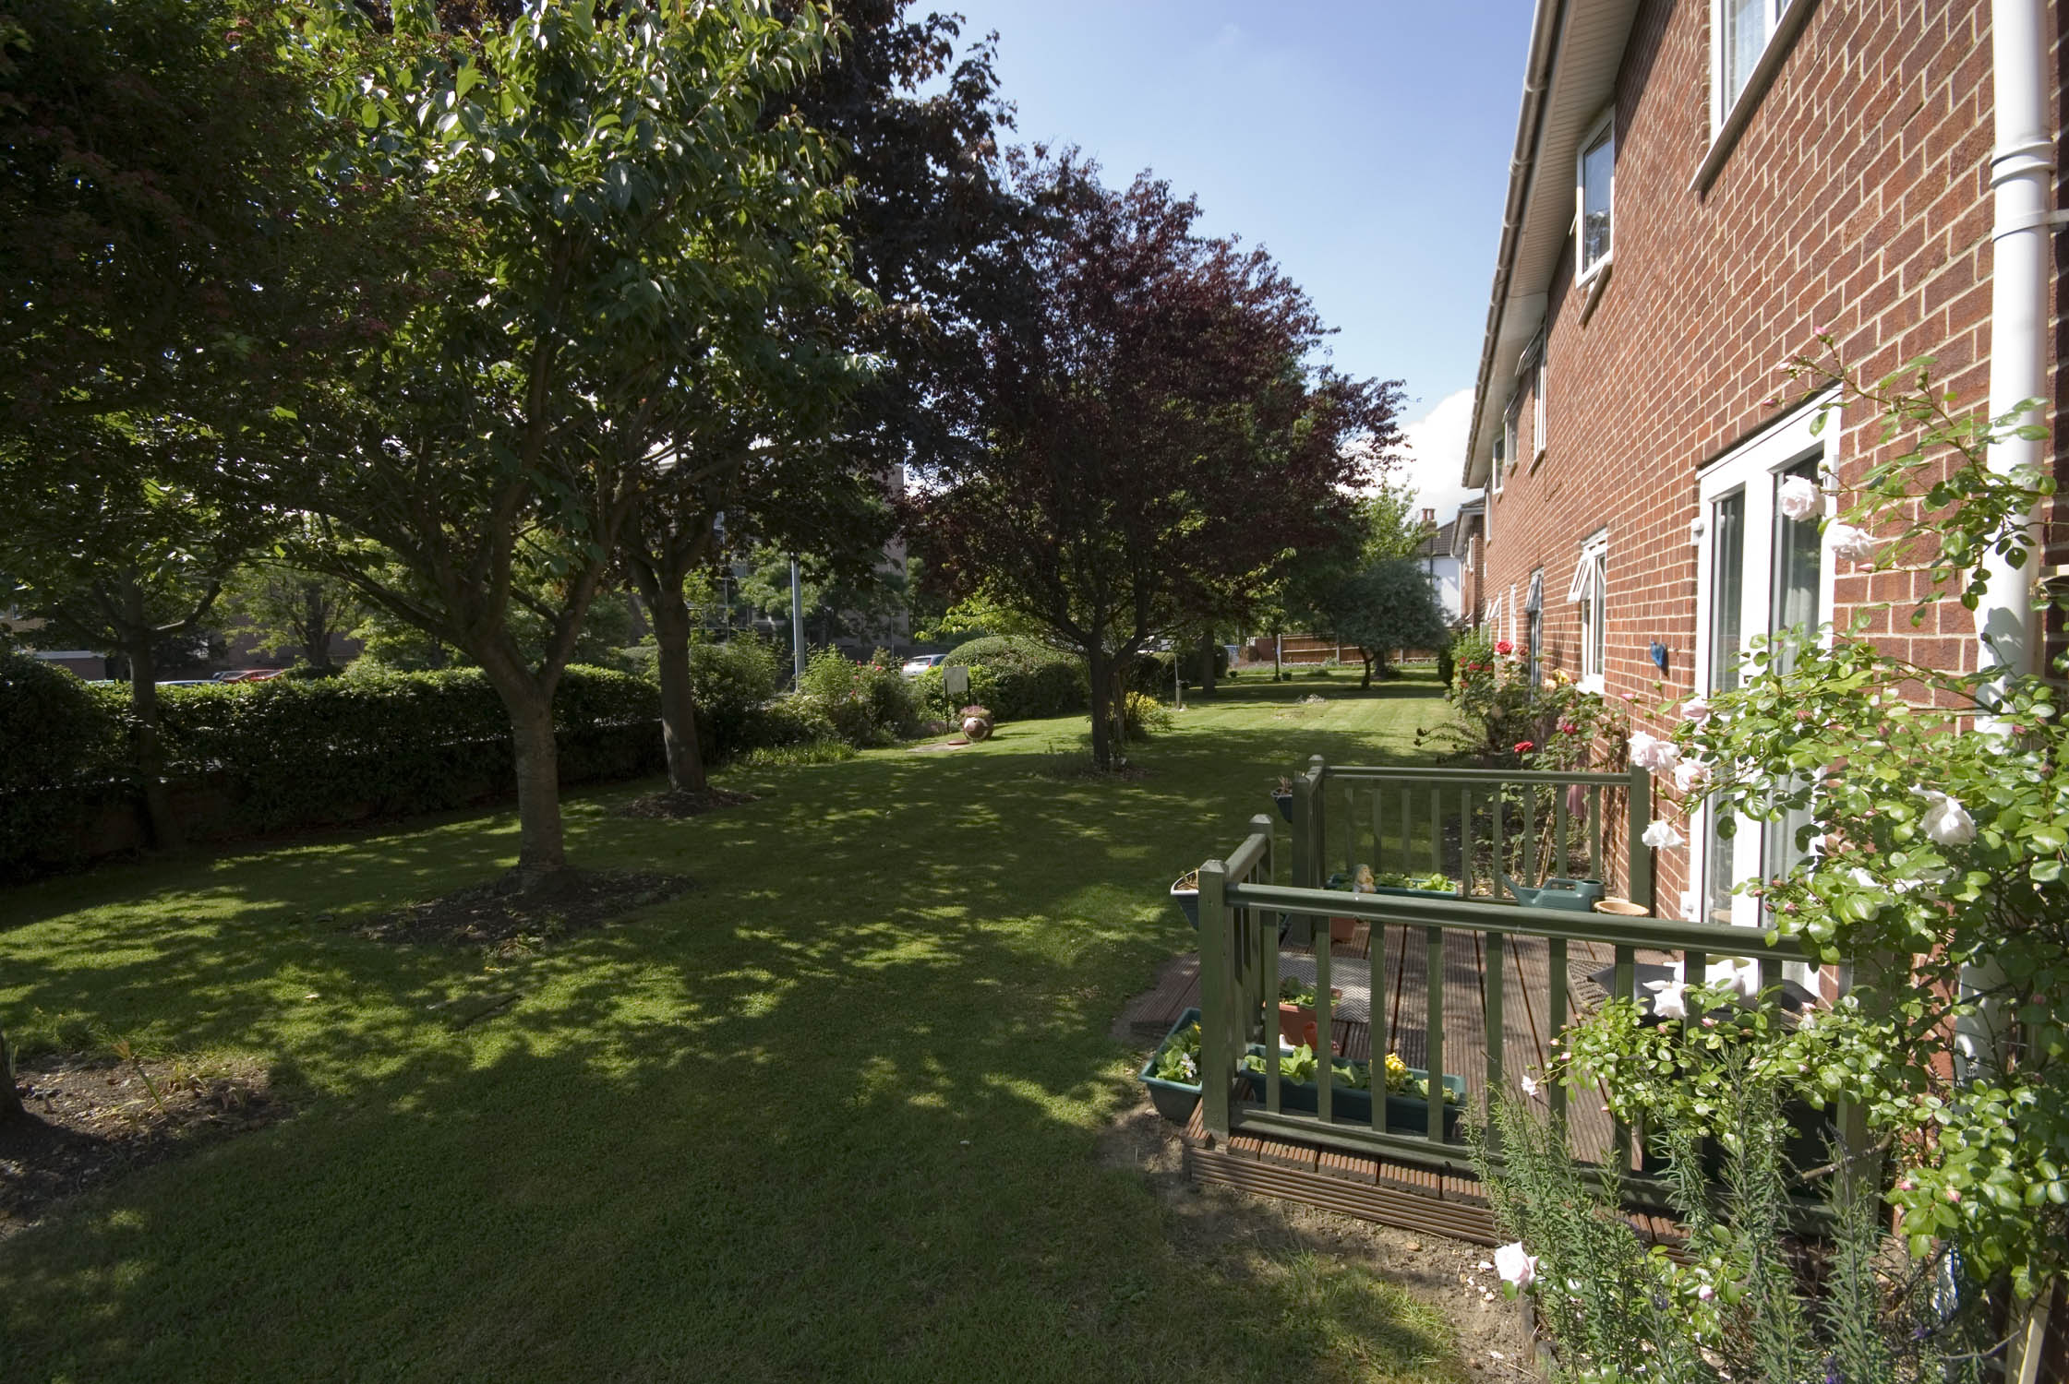
Contact details

To find out more, or to arrange a visit, please contact the scheme manager on 02380 466490 or our Customer Service Team on 0845 688 7717.


Registered office: Level 6, 6 More London Place, Tooley Street, London, SE1 2DA
www.affinitysutton.com

