
Providing Retirement Housing
in Basingstoke
MAGNOLIA COURT

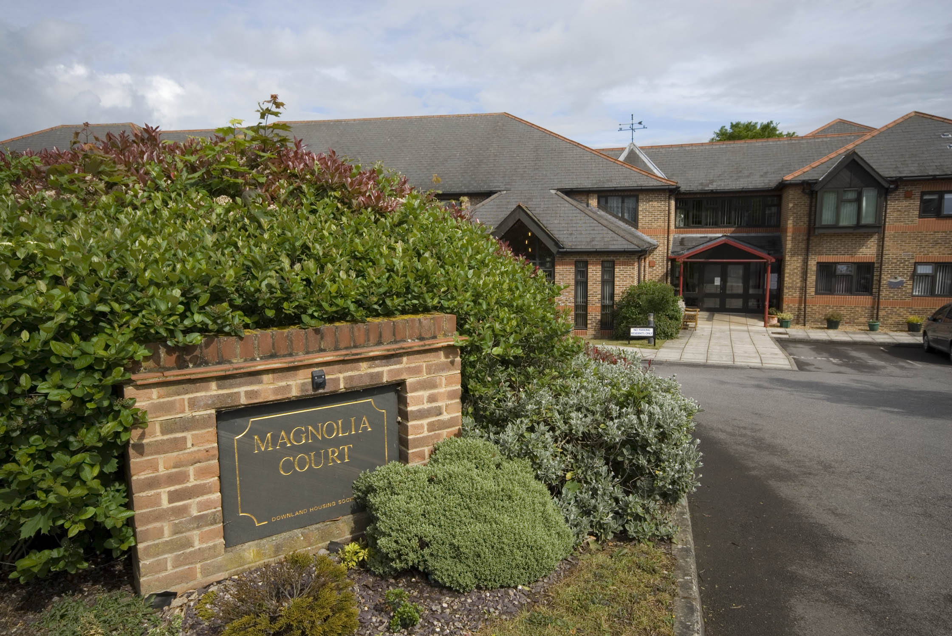

Magnolia Court
Popley
Basingstoke
Hampshire
RG24 9EX

Telephone:
01256 462140

About the scheme

Magnolia Court is situated in Popley, which approximately 3 miles from Basingstoke. The scheme has 31 homes specifically designed for older people, and offers an opportunity for independent living in a safe, comfortable and secure environment.

The scheme is set over 2 floors with lift and stairs to the upper floor. All the properties are one bedroom and offers spacious accommodation.

The local area offers GP Surgeries, dentist, a thriving community centre and various shops. Basingstoke has an abundance of recreational facilities, including a concert hall, theatre, sports centre and swimming pool. There is also Festival Place which offers a modern, shopping, eating, and leisure facility.

Basingstoke has very good bus links, both locally and to the near by towns of Newbury, Andover and Winchester.

Facilities
- 31 homes
- Lift
- Night storage heaters
- Communal lounge and adjoining kitchen, where coffee mornings, lunches and teas are regularly held
- Library
- 24 hour emergency support, 7 days a week, via our staff and our in house control centre
- Security door entry to the main front door that can be operated from each flat
- Communal laundry room with washing machines and dryers for residents
- Treatment room which is used by visiting a hairdresser and chiropodist
- Guest Suite for residents family and friends
- Stunning Communal Garden

Who can apply?

Magnolia Court has been specifically designed for older people or those with disabilities.
How to apply

Applications should be made to Basingstoke and Deane District Council – unless you are currently an Affinity Sutton resident.

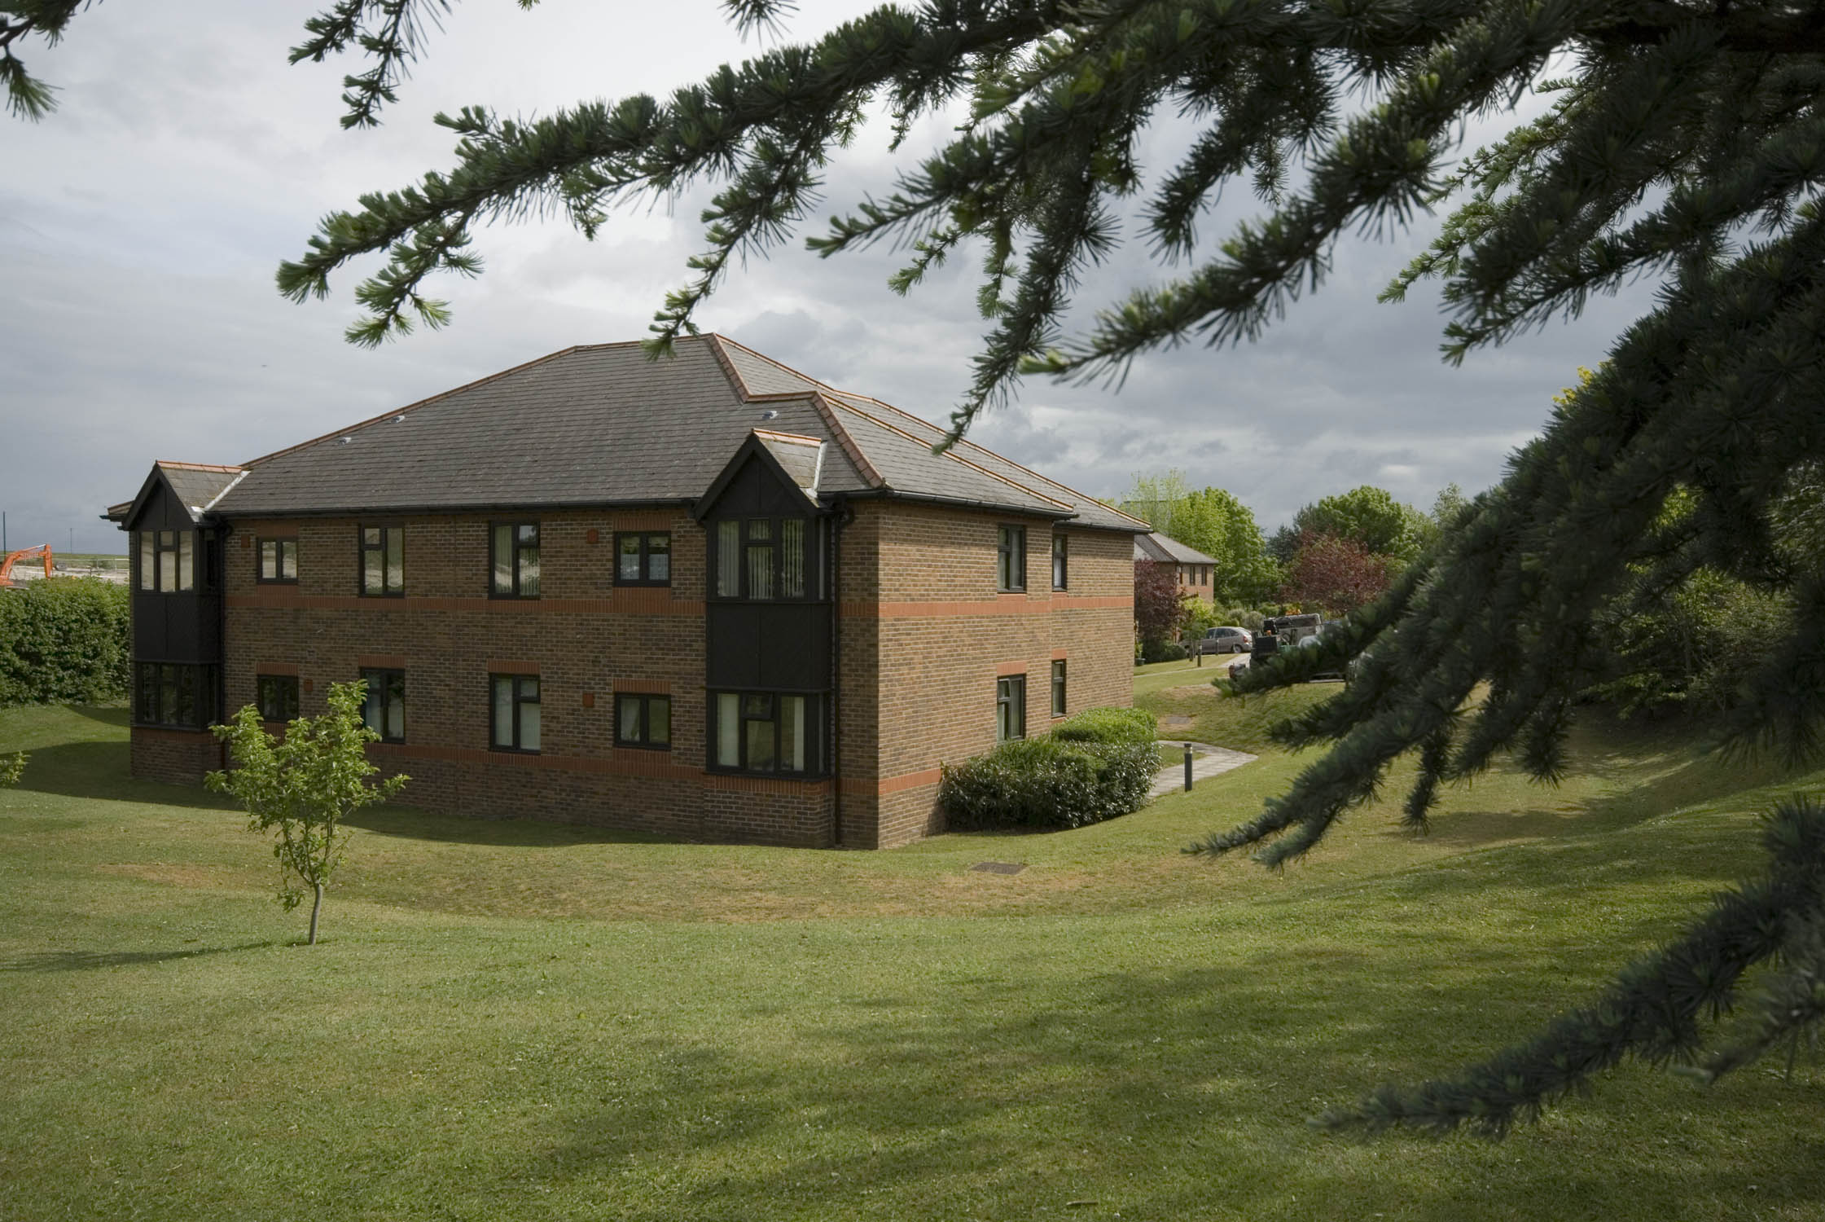

Contact details

To find out more, or to arrange a visit, please contact the scheme manager on 01256 462140, or our Customer Services Team on 0845 688 7717.


Registered office: Level 6, 6 More London Place, Tooley Street, London, SE1 2DA
www.affinitysutton.com

