Support for carers and
those being cared for...
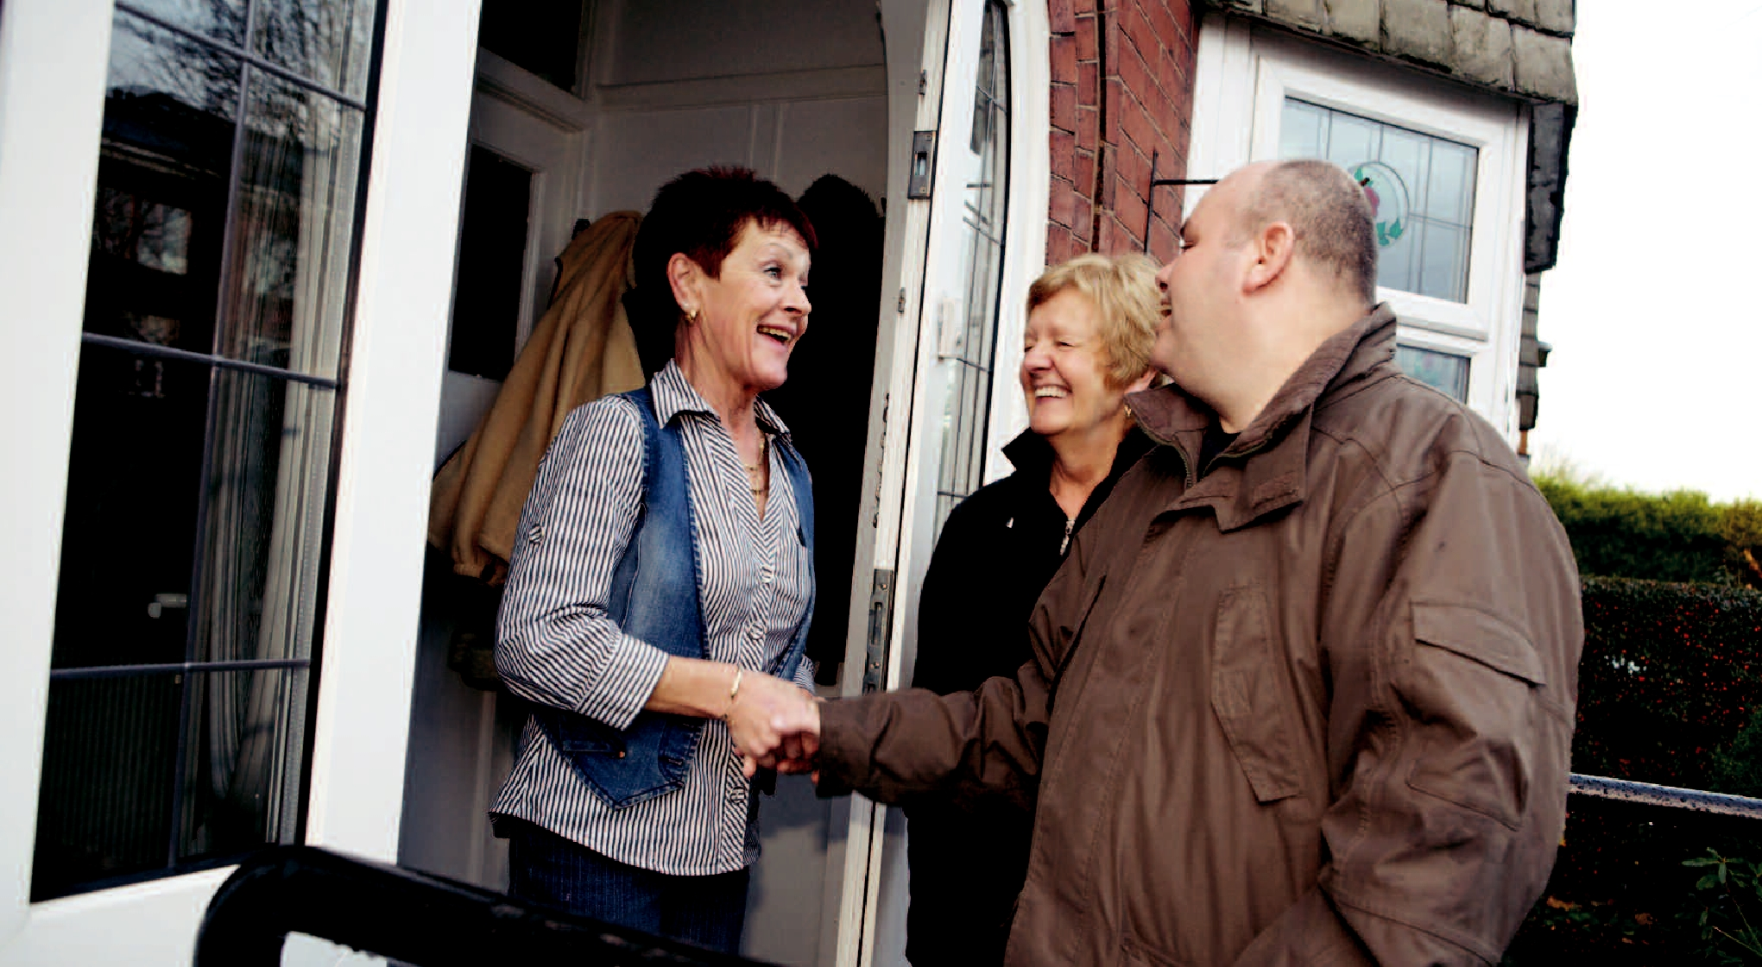

Short Breaks

Ensuring the best possible social care for the people of Bolton
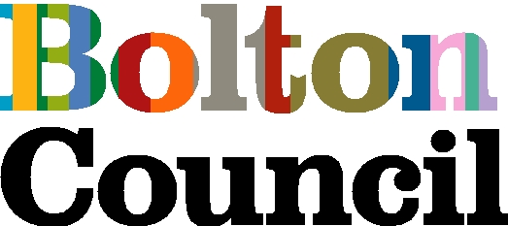
What is a short break?

If you, or the person you are caring for, are finding it hard to manage because of a long term illness, age or disability, you may be entitled to a short break.

To use short breaks, the person being cared for has to have eligible needs and a carers assessment must be completed.


If you want to know more

Contact your social worker/care manager.

If you do not have a social worker/care manager, please contact your local Adult and Community Services office at:

Access Bolton
Telephone: 01204 338027

North Short Term Assessment and Reablement (Post Codes, BL1, BL2, BL6 BL7) Telephone: 01204 333410

South Short Term Assessment and Reablement (Post Codes BL3, BL4, BL5) Telephone: 01204 337000

There are different ways to have a short break:
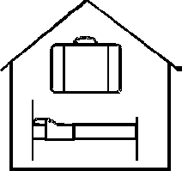

In a residential or nursing home.

With local approved families in their home.


Staying at home with support from carers during the day
and night time.

or
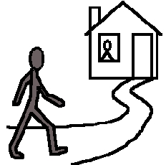


➔ You may choose to take the money and buy a service,
or employ independent staff to support you directly – we
call this a Direct Payment.




Bank


You will be charged for these services

Costs

We charge a standard rate for the first 6 weeks of any short break and this leaflet gives information on how these charges are reached.

The cost will depend on the savings and/or age of the person needing care/support

If you have more than £23,250 in savings you will need to pay the full cost.

Please note:

Costs may vary, dependent on the type of short break you choose.

If you have less than £23,250 in savings your contribution will
be:

From 7 April 2014

For those aged:

18-62 years olds: £83.75 per week

63 years and over: £123.95 per week

Department of Works and Pensions


DWP Before you receive this service, please tell the Department for Works and Pensions of this change in your financial circumstances.
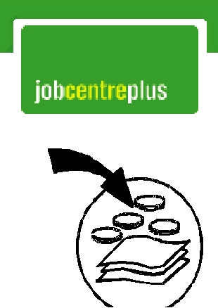

It may be that you could claim Income Support or Pension Credit.

or


There may be an effect on your benefits.


It is very important that you contact them before you have your short term break.

What do I need to do next?


If you have more than £23,250 in savings you can make your own arrangements if you choose.

If you are not making your own arrangements


You or the person who helps you manage your money will need to fill in the attached declaration of finances form and then pass it onto your social worker.


This form will enable us to provide you with an accurate charge for the care you are or will be receiving.

How will I pay my charges?


After your short break we will send you or the person who supports you with your money a bill.


The bill will have full details of the dates of your stay and will also tell you about different ways you can pay your bill.

What if my stay is extended?
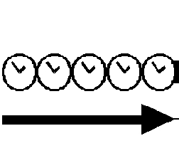

If your stay is extended for longer than 6 weeks in total we will need to complete a financial assessment.
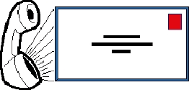

If this happens we will contact you or the person who helps you with your money, to arrange this.

Will I be entitled to any state benefits?
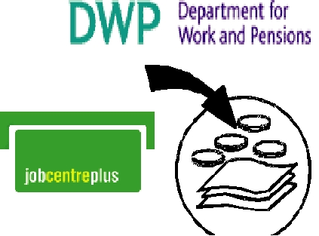

You may be able to claim Income Support/Pension Credit etc, towards the cost of your care (depending on the level of income you already have coming in).

The telephone numbers for:


Pension Credit claims 0800 991234

Getting in touch with Adult Services

Access Bolton
Telephone: 01204 338027

North East Short Term Assessment and Reablement (Post Codes, BL1, BL2, BL6 BL7) Telephone:01204 333410

South East Short Term Assessment and Reablement (Post Codes BL3, BL4, BL5) Telephone: 01204 337000

For a sudden emergency out of normal office hours, weekends or bank holidays

Telephone: 01204 337777

If you would like this information in large print

or on


Audiotape

Please telephone 01204 337260

