Gardens

Delph House is set in 2 ½ acres of landscaped gardens. There is a smooth path running all round the buildings to make walking safe and easy, and residents and visitors are encouraged to go out and enjoy the shrubs and flowers. There are garden seats within reach and a summer house in one corner of the lawn.

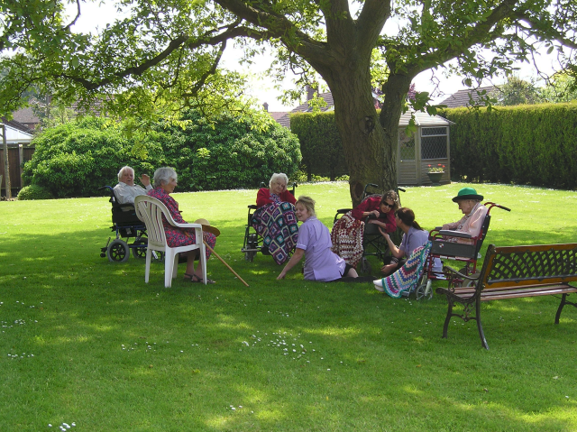

Further information
We are situated on the A1101 between Littleport and Wisbech. Other towns within easy reach include Downham Market, March, Chatteris and Ely.

If you would like more information, or to arrange a visit, please contact the partners Teresa or Graham, on 01354 610 300. or visit our web-site www.delph-house.co.uk

Marifa Care Home is registered with the Commission for Social Care Inspection as a Residential Care Home for the Elderly.

Email: info@delph-house.co.uk

Marifa Lodge Care Home

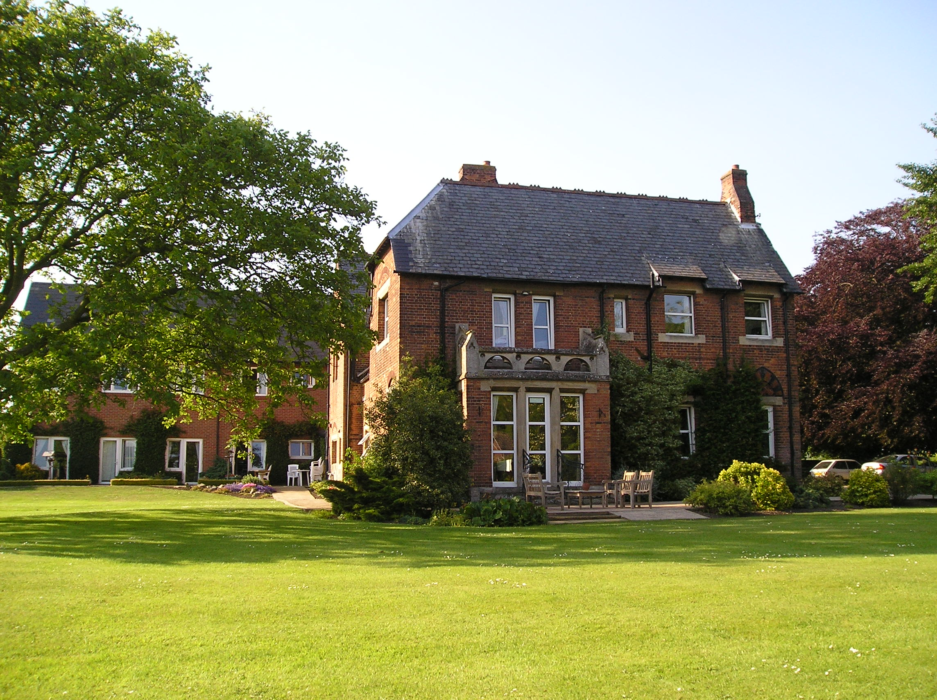

Delph House

Wisbech Road
Welney
Wisbech
PE14 9RQ

Tel: 01354-610 300

www.delph-house.co.uk
Our home

Delph House is the former rectory, extended and pleasantly situated in the attractive and unspoilt Fenland village of Welney. Our home has a friendly family atmosphere, is set in delightful landscaped gardens and is close to village amenities including the pub and restaurant, and the Welney Wildlife Trust which attracts many visitors.

The most vital resource within Delph House is our friendly and committed team of staff. Moving into a care home can be a difficult time for residents and their families alike. Our staff will help to make the move as easy as possible by carefully identifying individual needs, regularly reviewing them, and always treating clients with professionalism and dignity.

From the main hallway visitors will pass the main lounge with its views of the gardens, and the dining room. The smaller lounge is at the other end of the building. Both lounges are equipped with TV and video players as well as comfortable chairs and small tables for tea.

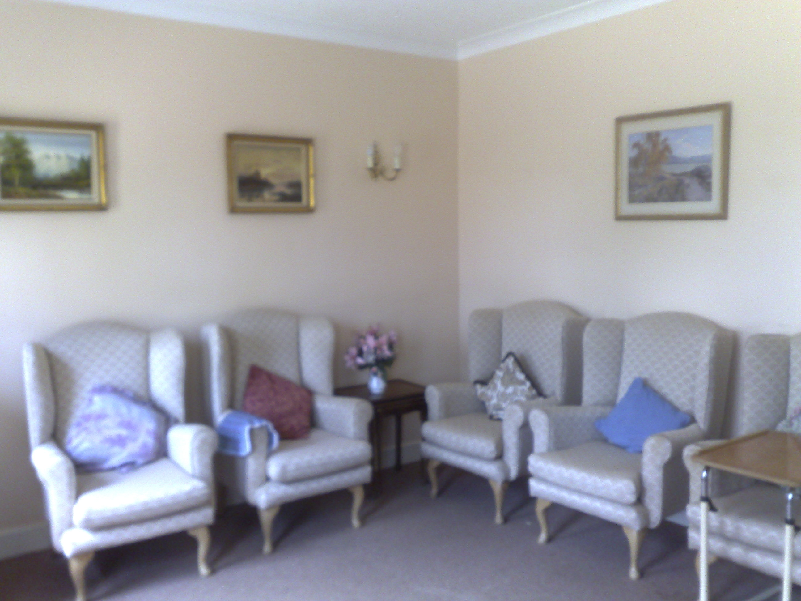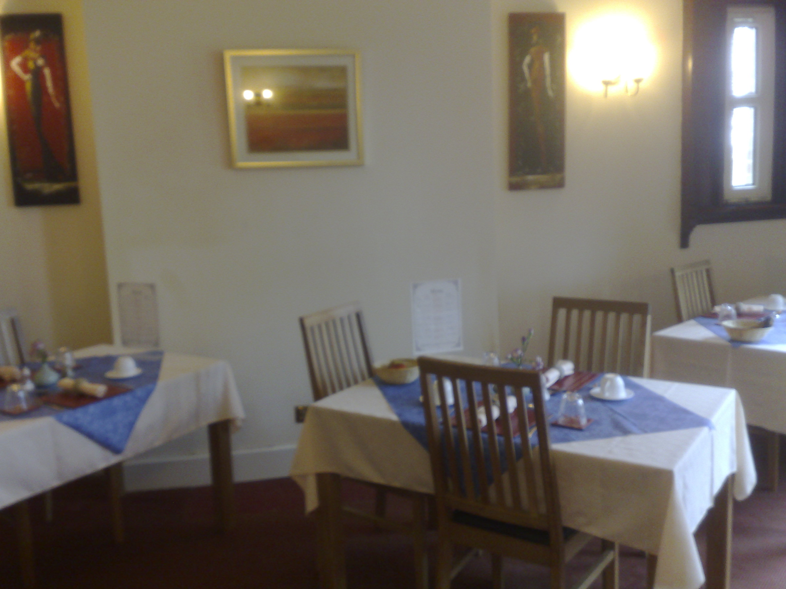

The small lounge | The dining room

Highlights of the day include the appetising meals served in the newly re-decorated and re-furnished dining room, or in the resident’s own room if they wish; its their choice. Light refreshments are served in the lounges also.

The menu always includes alternatives to the main dish offered, and residents are asked for their preferences. The smaller lounge also houses a library, including large-print books, which are regularly replaced, from the public library.

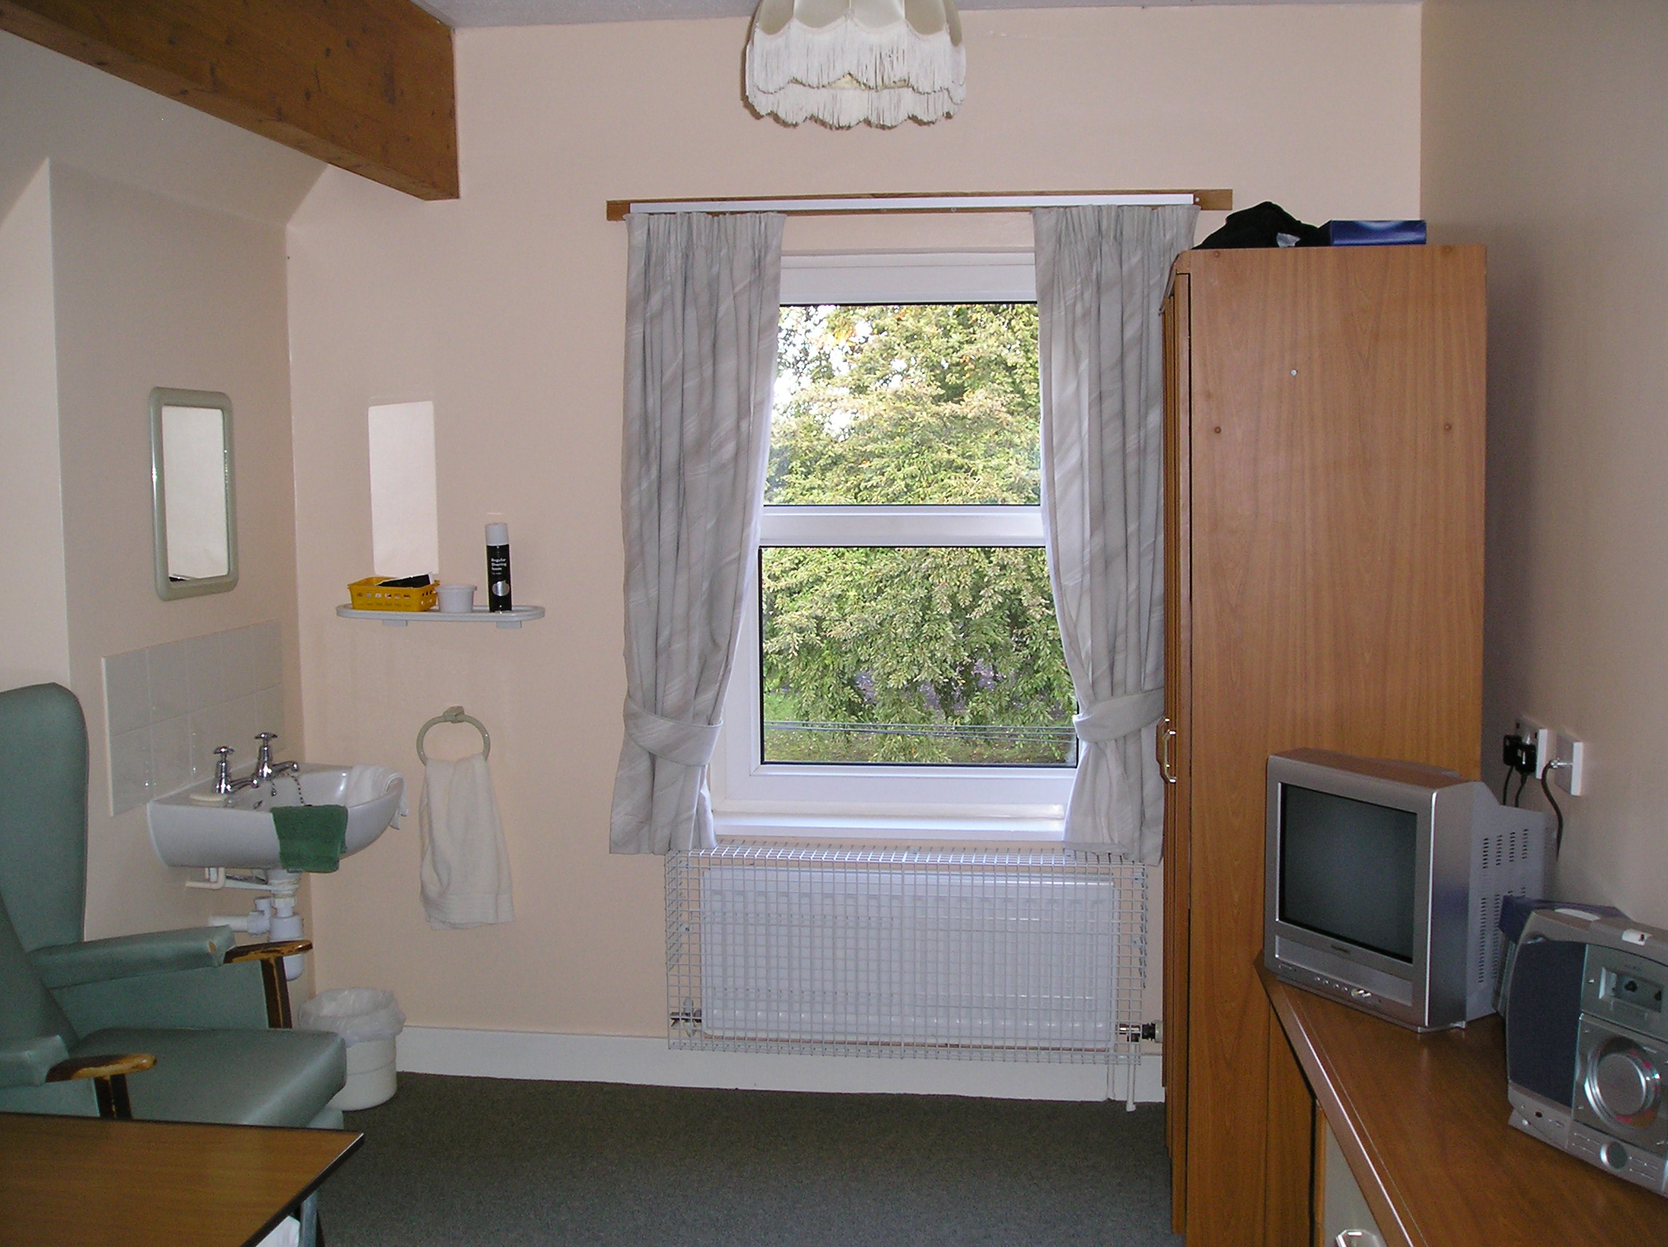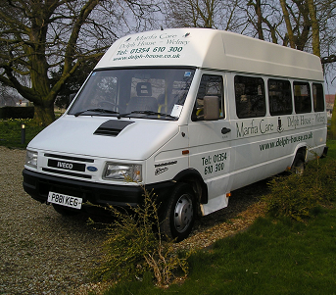
A single bedroom | Our mini-bus

Lifestyle

At Delph House we encourage a full and active lifestyle. We have our own minibus with disabled access, and normally organise a trip out every week, for those who wish to take part. We visit places of interest and also shopping venues, for example Ely market. We also organise afternoon activities for those residents who wish to participate within the home. There is a genuine family atmosphere within the home and residents help and encourage each other.

We know how important it is to keep in touch with friends and relatives, so guests are always welcome. Any of the lounges and garden areas are available for guests to meet with residents, as well as the resident’s own room.

Residents are always encouraged to bring personal belongings, such as pictures, ornaments and suitable items of furniture. A resident’s room is their own, and staff will always knock and wait to be invited in.

